To design and deploy a multi-tier architecture on Azure for hosting a WordPress website, you can follow these steps:

**1. Resource Deployment:**

**Azure Web Servers:**

* Deploy virtual machines to act as web servers using Azure Virtual Machines.
* Choose appropriate VM sizes and configurations based on your website's traffic and resource requirements.
* Install necessary web server software like Apache or Nginx.
  + Log in to the Azure portal (portal.azure.com).

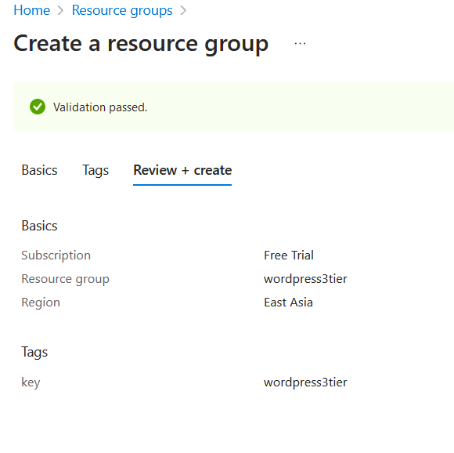

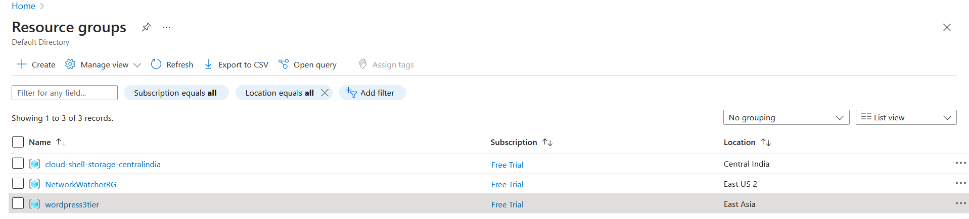

* + Click on "Create a resource" > "Compute" > "Virtual Machine".
  + Fill in the required details such as VM name, region, resource group, and VM size.

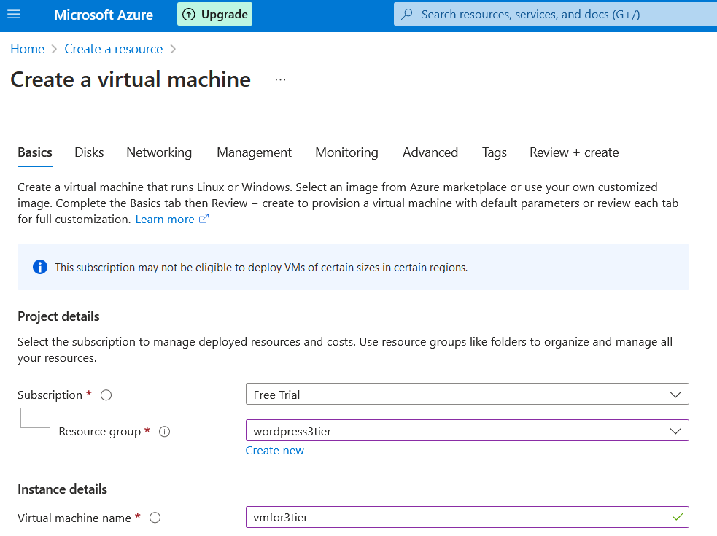

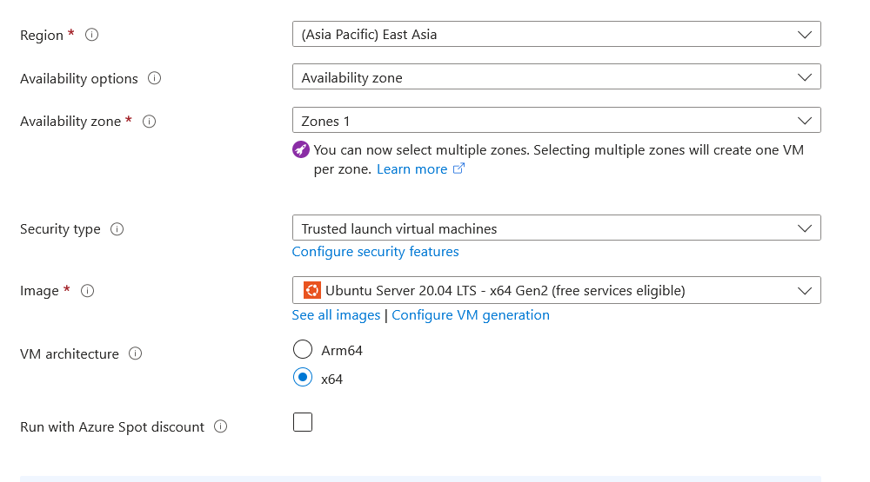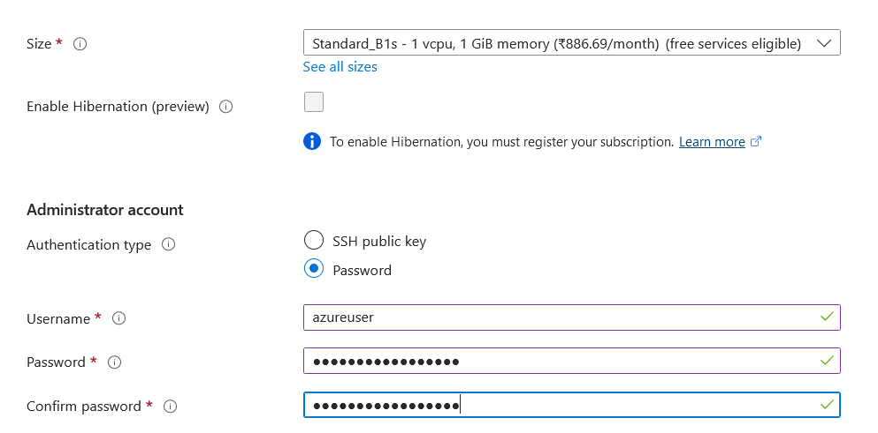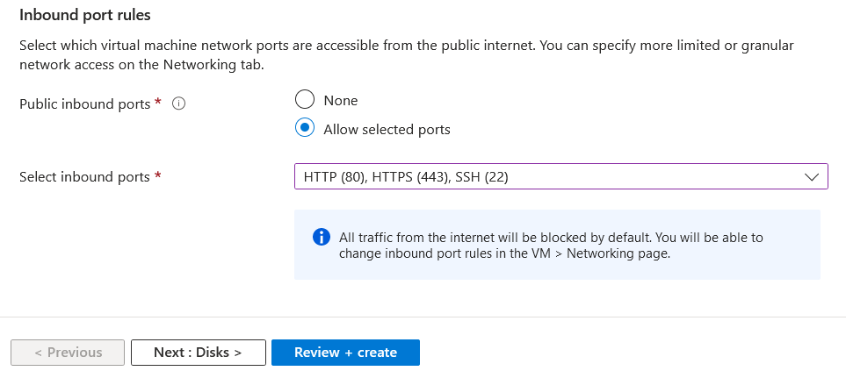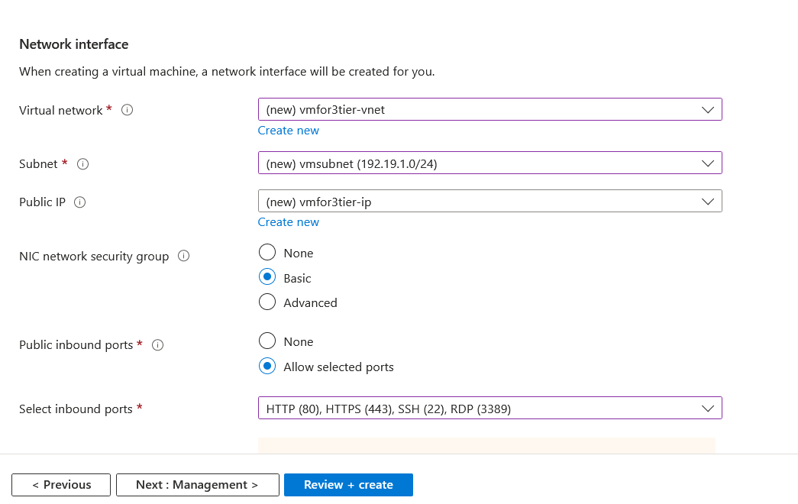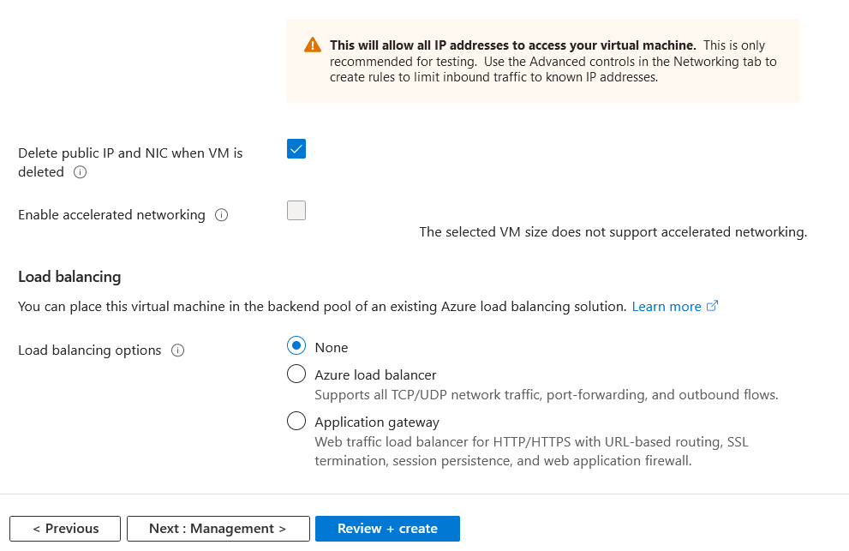

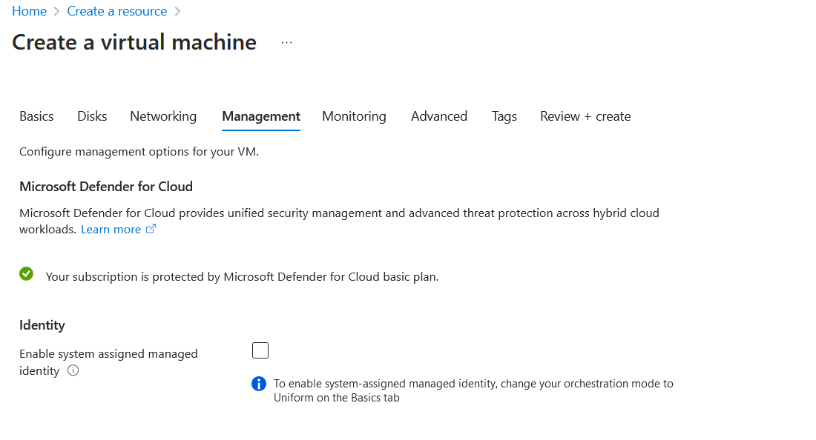 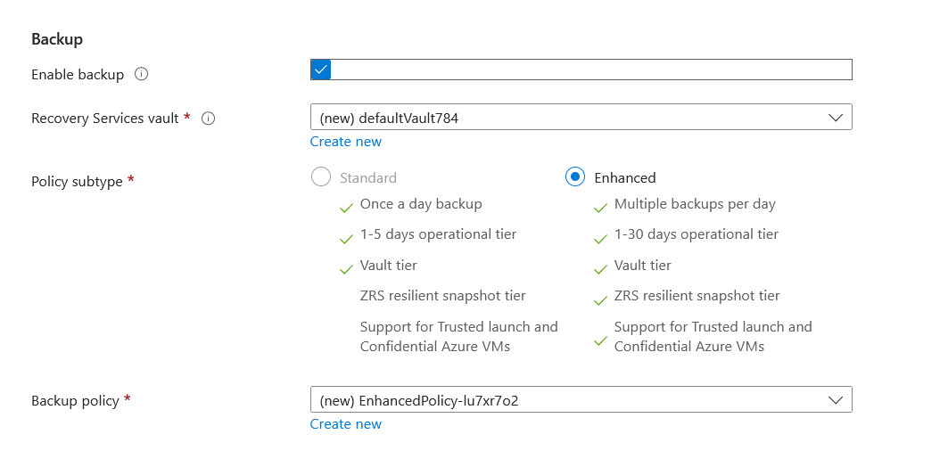 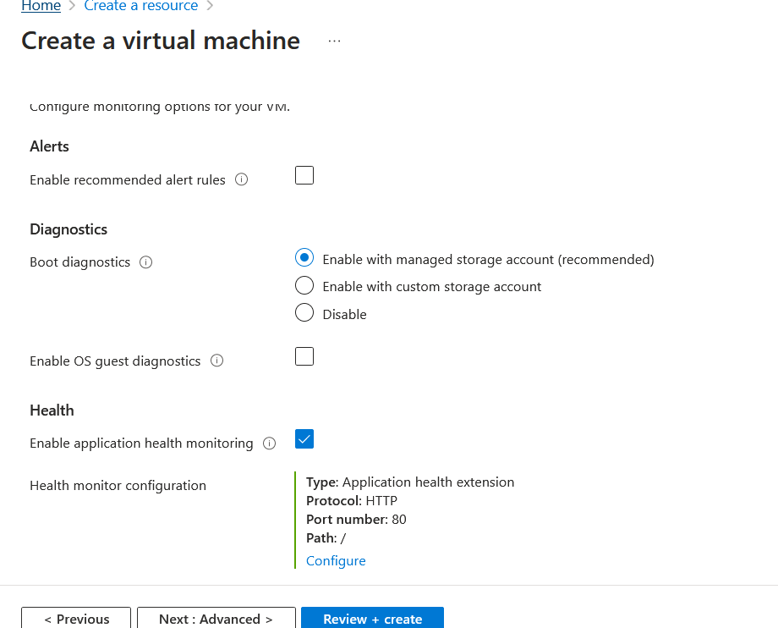

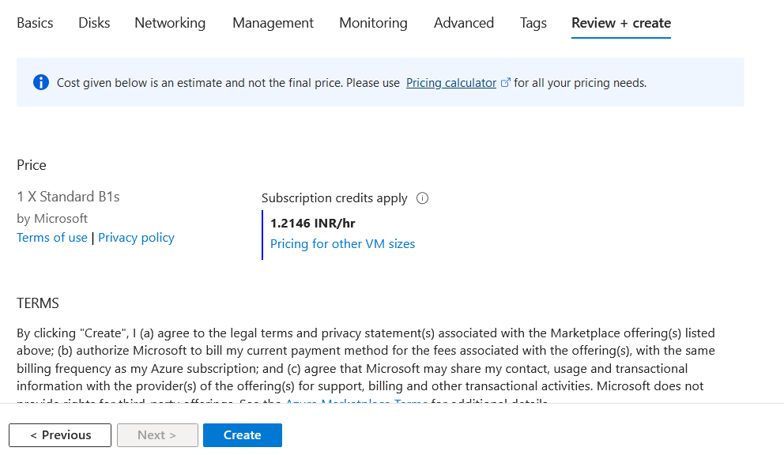

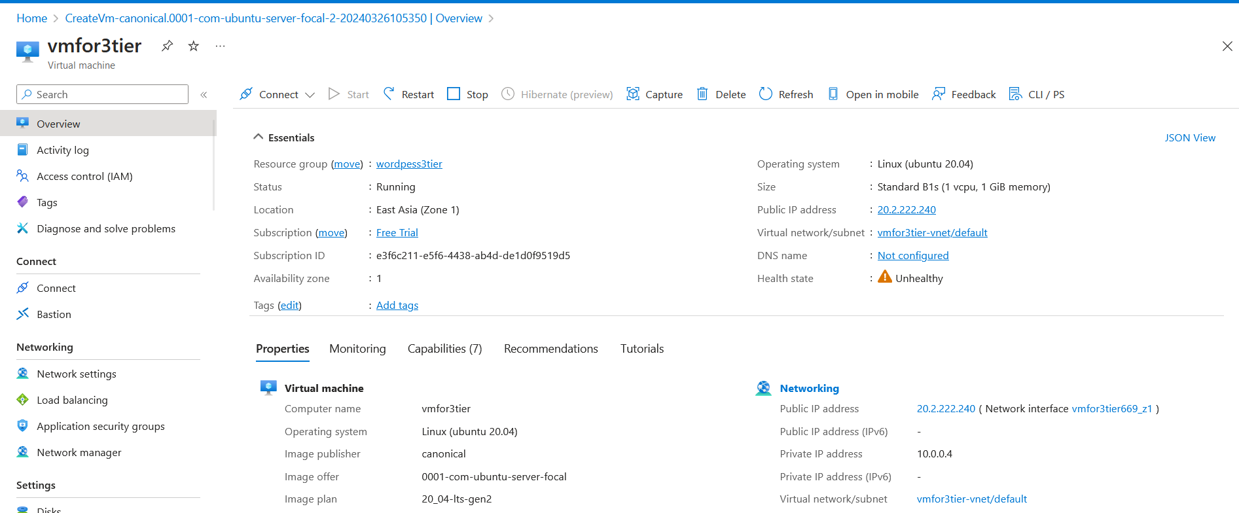

* + Choose "Ubuntu Server" as the operating system image for your VM.
  + Configure networking settings, including virtual network, subnet, public IP address (if needed), and network security group.

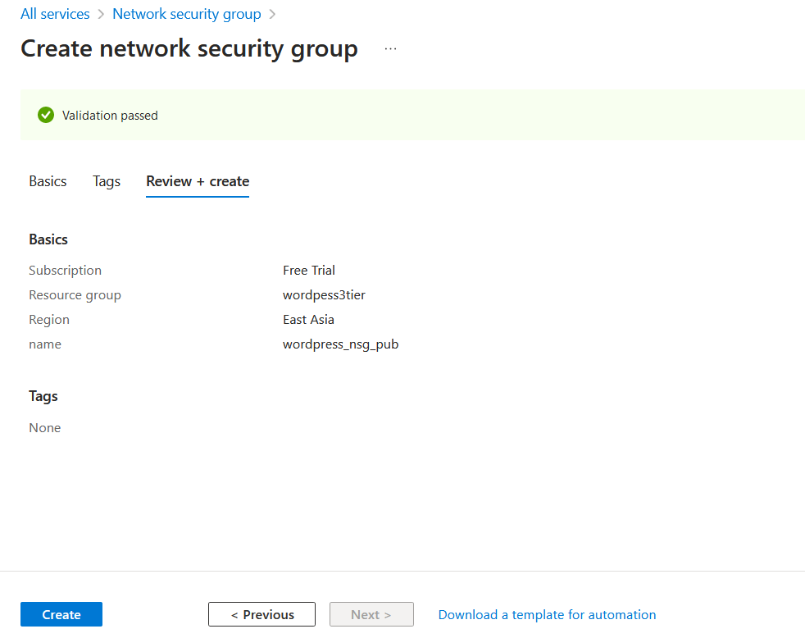 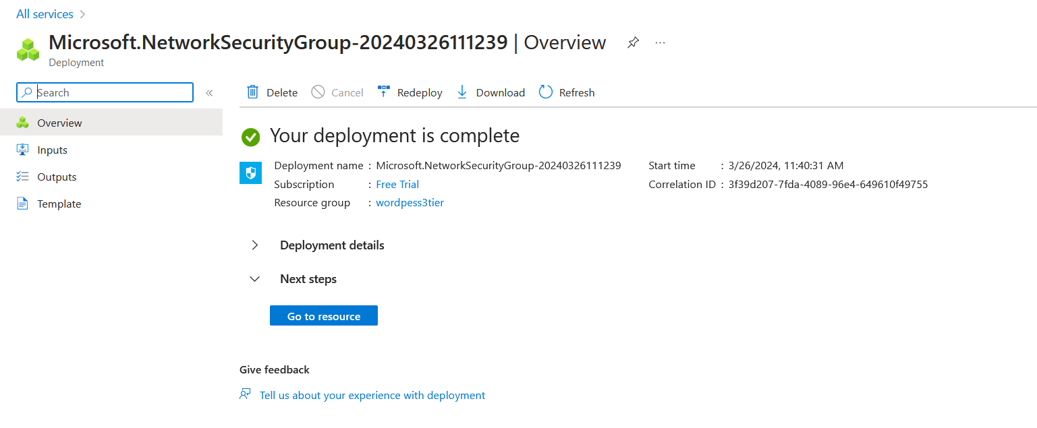

**Azure Application Servers:**

* Deploy virtual machines to run PHP and support the WordPress application.
* Again, choose VM sizes and configurations based on resource requirements.
* Install PHP and other dependencies required to run WordPress.

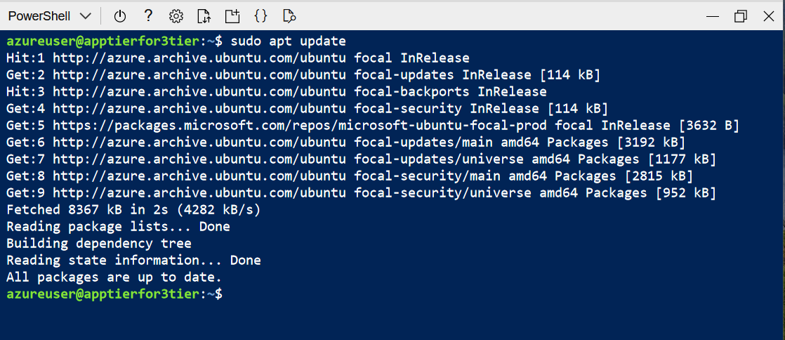



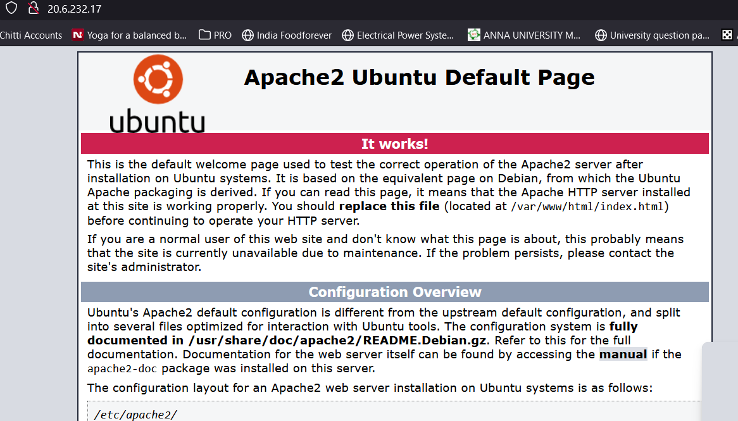



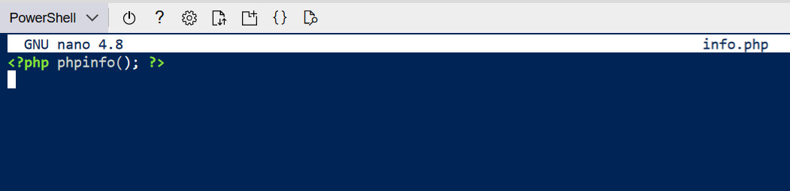

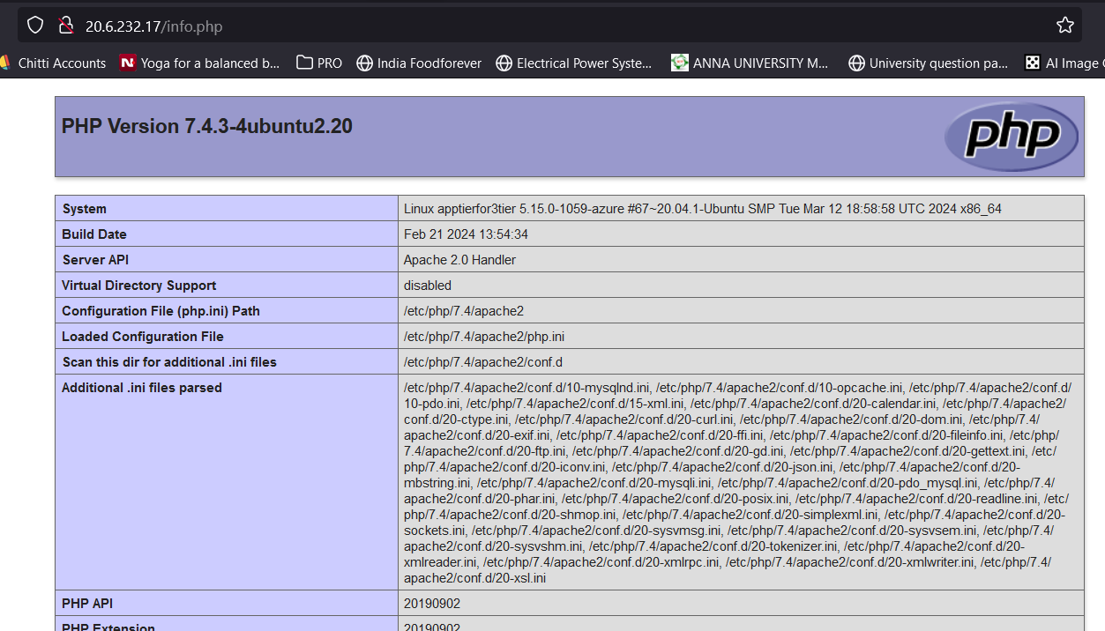

**Azure Database Server:**

* Choose either Azure Database for MySQL or deploy a virtual machine to host a MySQL server.
* Configure appropriate storage and networking settings.
* Ensure the database server has sufficient resources to handle the website's data needs.

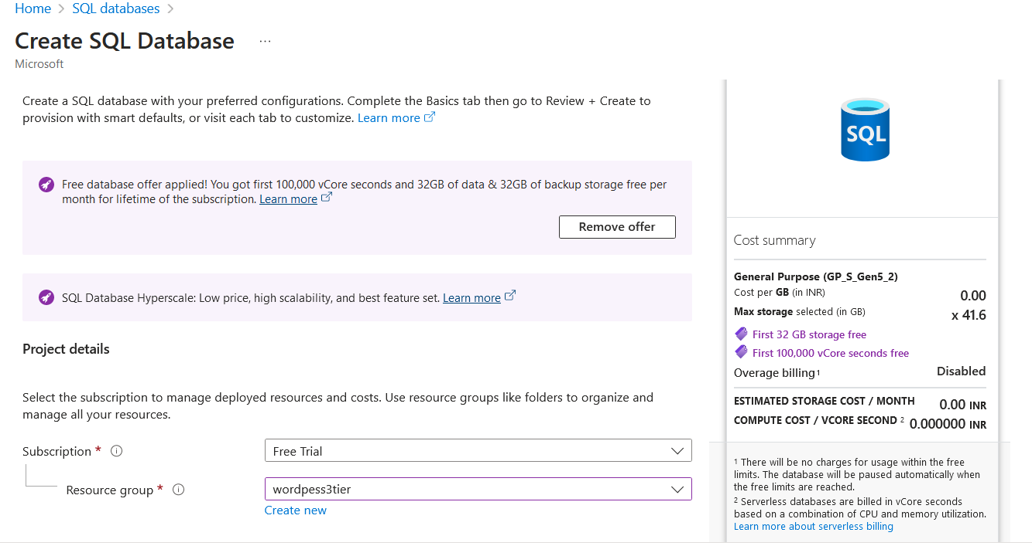

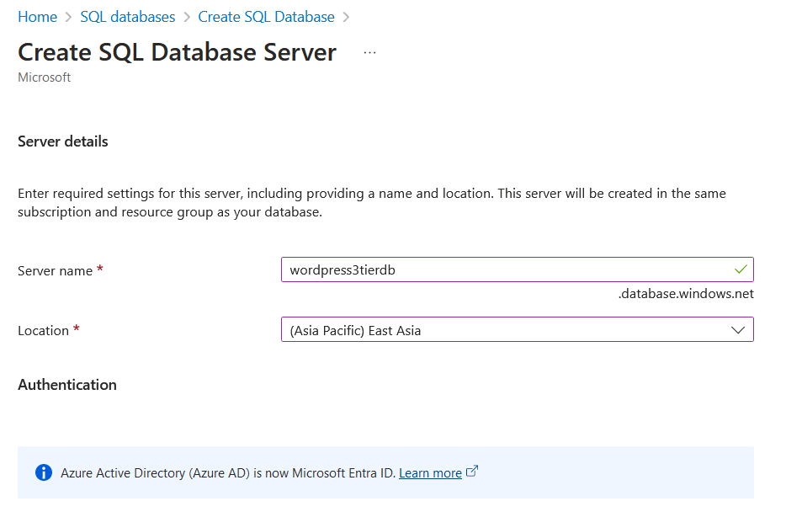 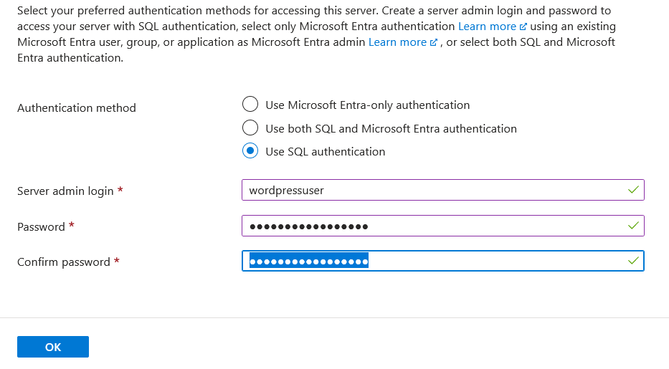

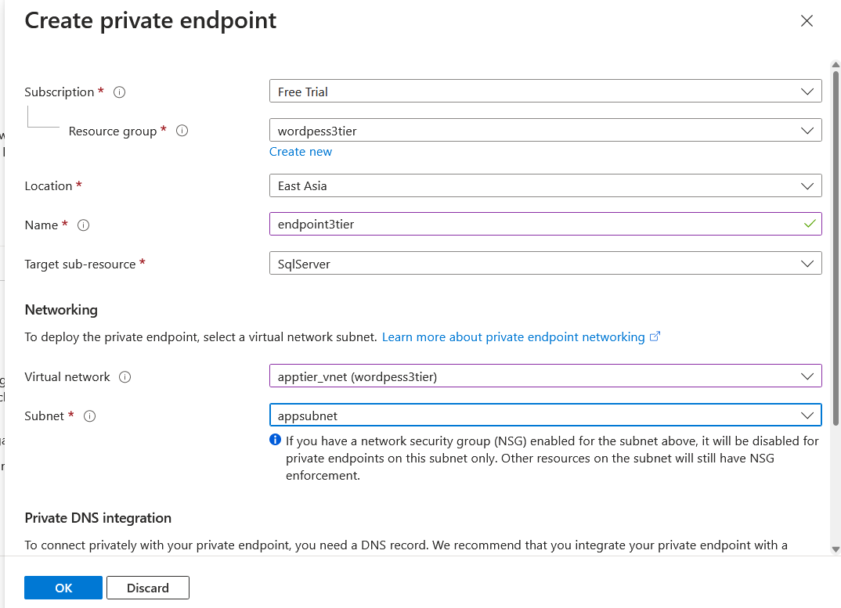 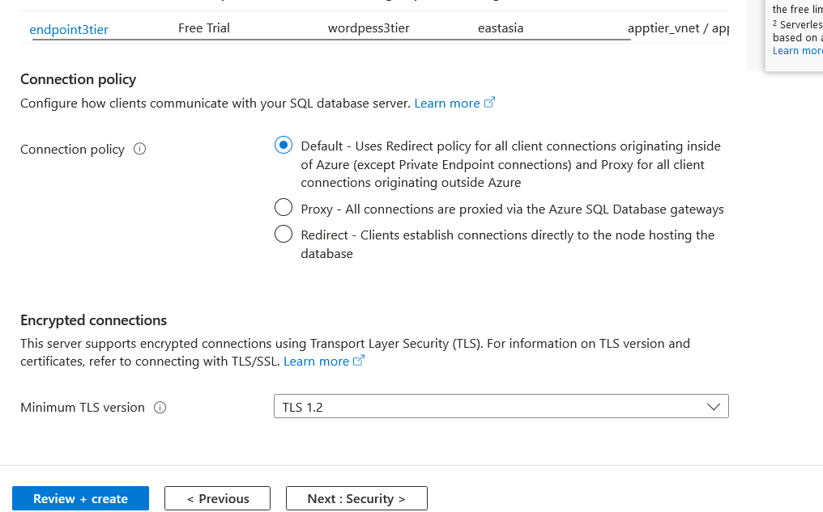 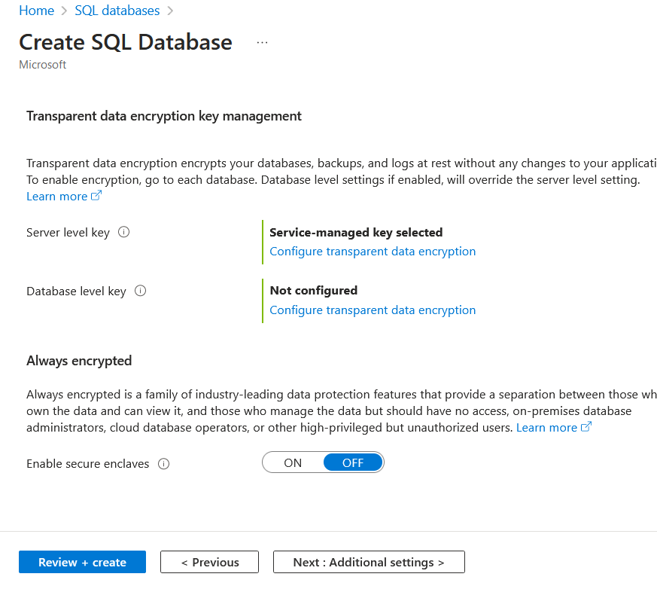 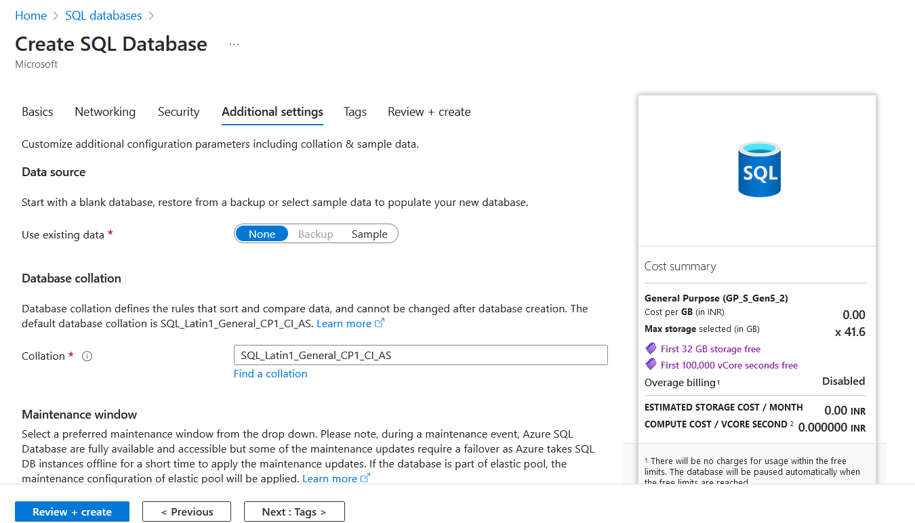 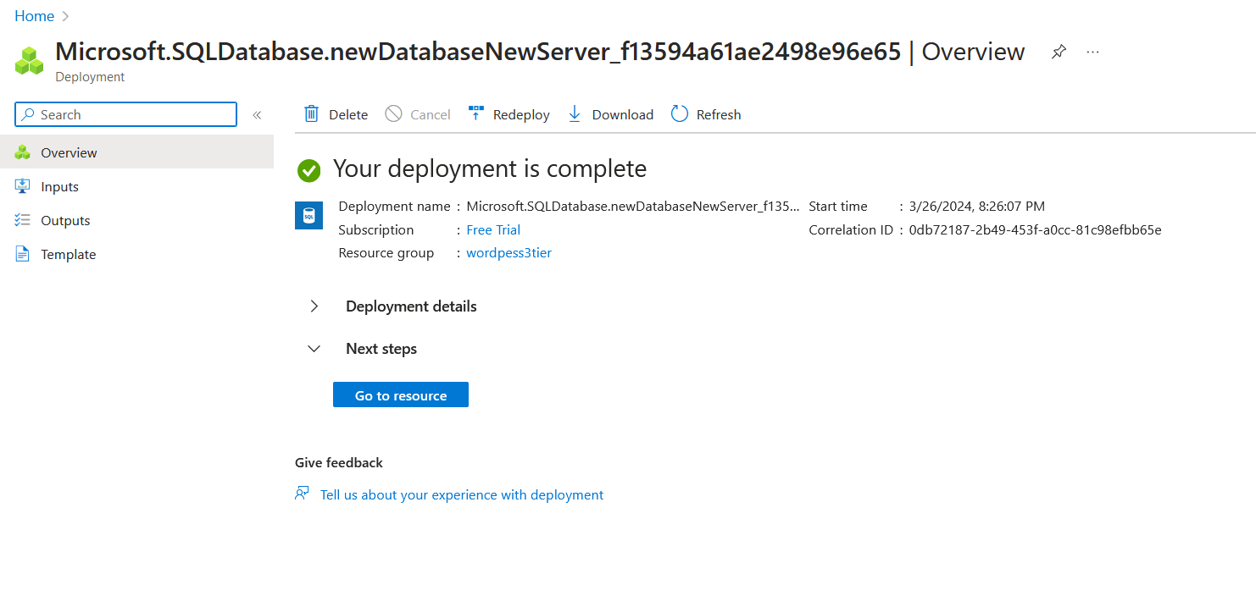

Create a new plugin to store comments in the database

**2. WordPress Installation and Configuration:**

* Connect to the web server VMs.
* Download and install WordPress.
* Configure WordPress to use the MySQL database server for data storage.
* Customize WordPress settings and themes as per your requirements.
  + Once the VM is created, connect to it using SSH.
  + Use an SSH client like PuTTY (for Windows) or the terminal (for Linux/macOS) to connect to the VM.
  + Use the username and SSH key specified during the VM creation process to log in to the VM.
* **Install LAMP Stack:**
  + Update the package index on your Ubuntu server: sudo apt update.
* 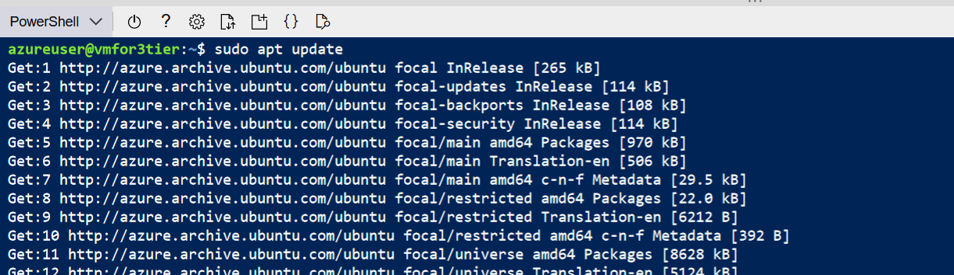
  + Install Apache, MySQL, and PHP:
* 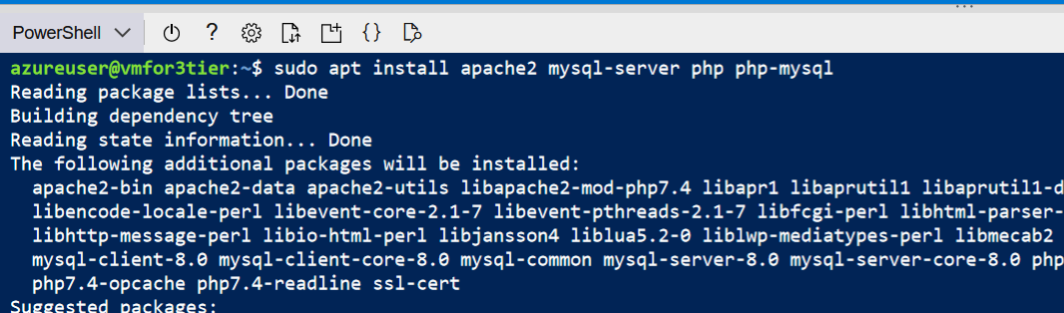
* 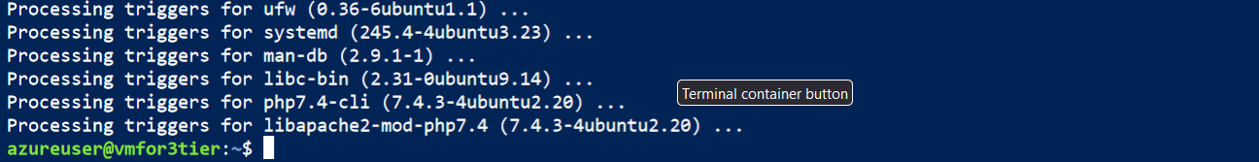
  + - bash
* •
* sudo apt install apache2 mysql-server php php-mysql
* sudo systemctl enable apache2
* sudo systemctl start apache2
* sudo systemctl enable mysql

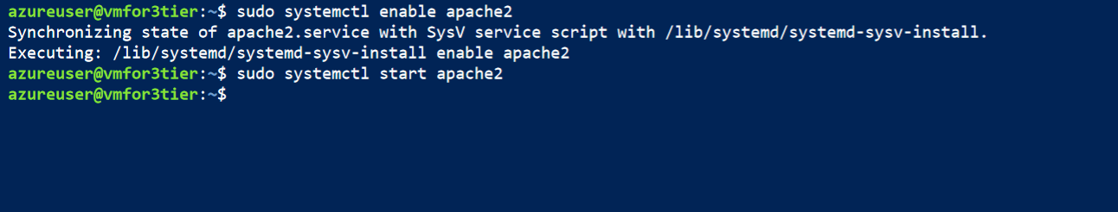 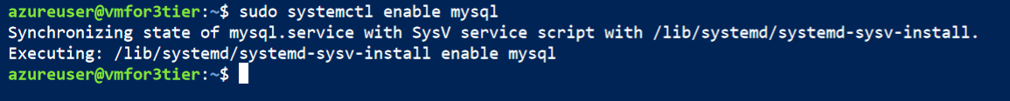

* • **Secure MySQL Installation:**
* Run the MySQL secure installation script: sudo mysql_secure_installation.
* Follow the prompts to set a root password, remove anonymous users, disallow remote root login, and remove the test database.

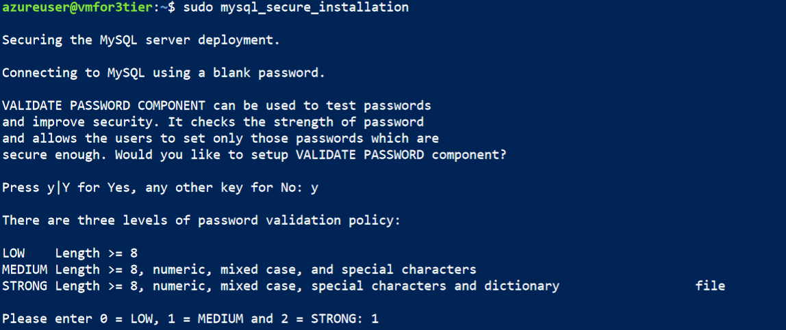 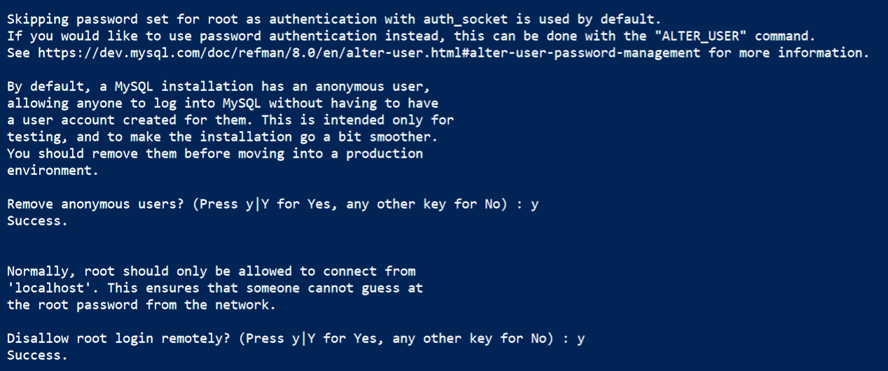

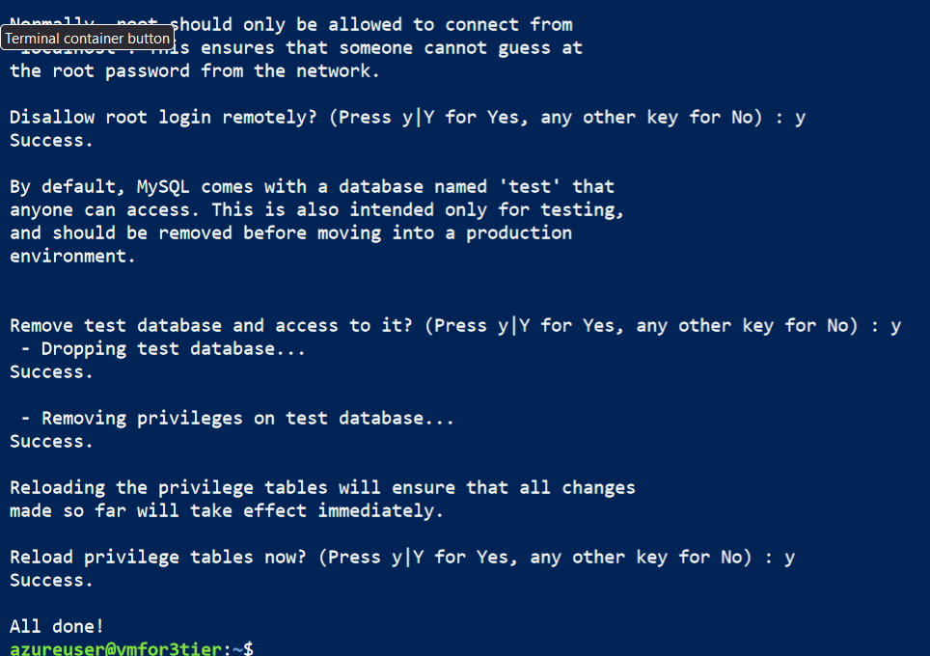

* 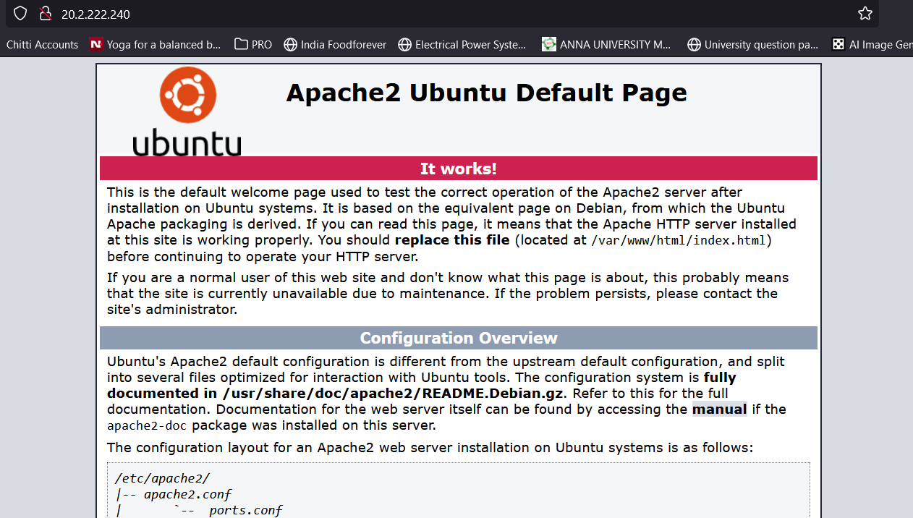
* **Create a MySQL Database and User for WordPress:**
* .



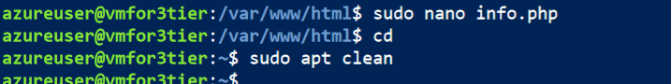

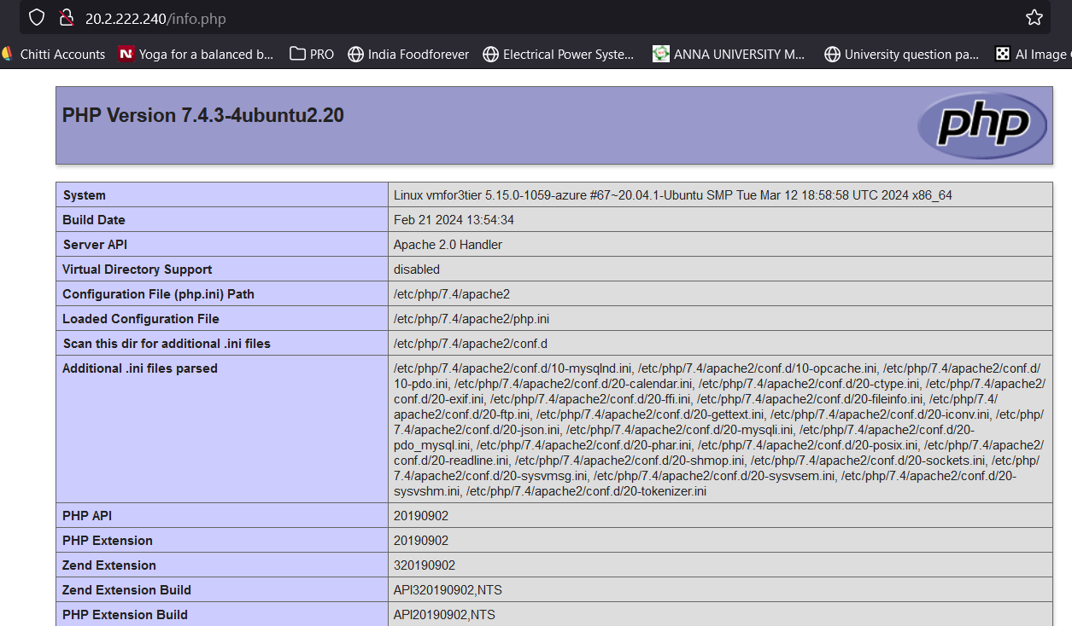

* Log in to MySQL as the root user: sudo mysql -u root -p
* Create a new database for WordPress: CREATE DATABASE wordpress;.
* Create a new user and grant privileges to the WordPress database:
  + CREATE USER 'wordpressuser'@'localhost' IDENTIFIED BY 'password';
  + sql

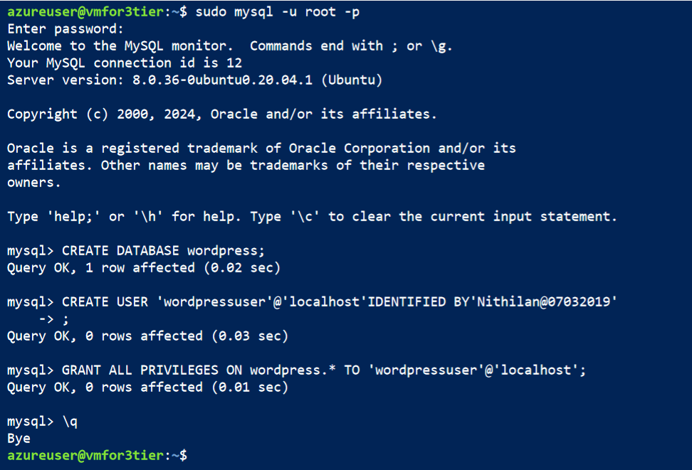

* GRANT ALL PRIVILEGES ON wordpress.* TO 'wordpressuser'@'localhost';
* • **Install WordPress:**

• Once connected to the VM, navigate to the web server's document root directory. For Apache, it's typically /var/www/html/.

• Download the latest version of WordPress using wget:

• wget <https://wordpress.org/latest.tar.gz>

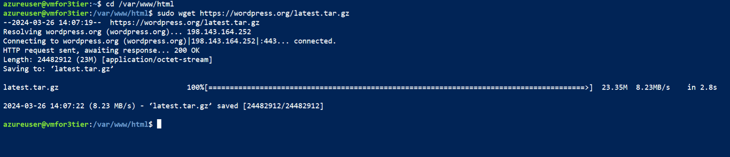

• Extract the downloaded WordPress archive:

• tar -zxvf latest.tar.gz

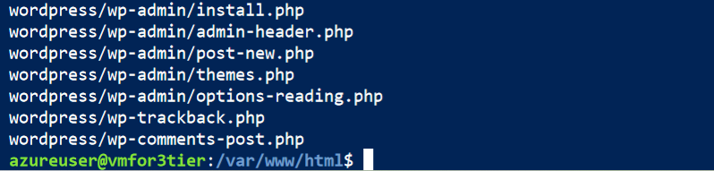

• Move the WordPress files to the document root directory:

bash

• sudo mv wordpress/* /var/www/html/

• Set appropriate permissions for the WordPress files:

kotlin

* •
* sudo chown -R www-data:www-data /var/www/html/

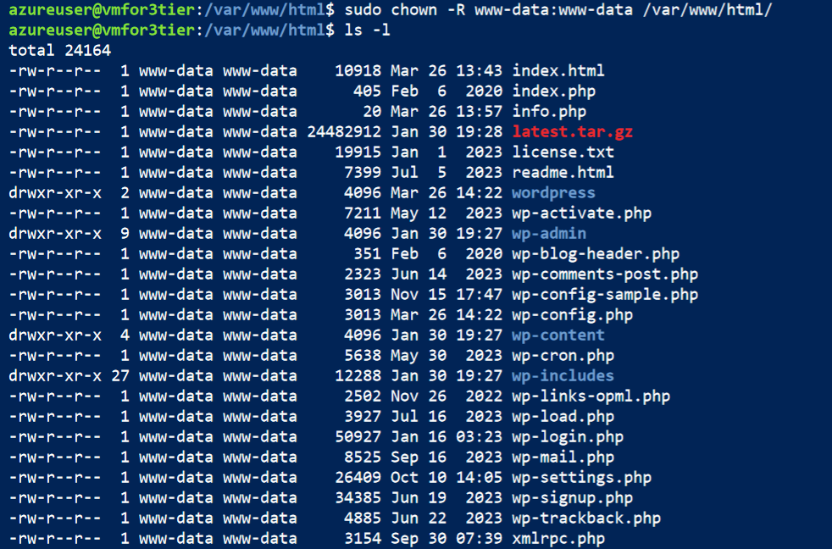

Replace www-data:www-data with the appropriate user and group if using a different web server configuration.

• **Configure WordPress**:

* + Navigate to the WordPress site in a web browser to start the installation process. It's typically accessed via the server's IP address or domain name.

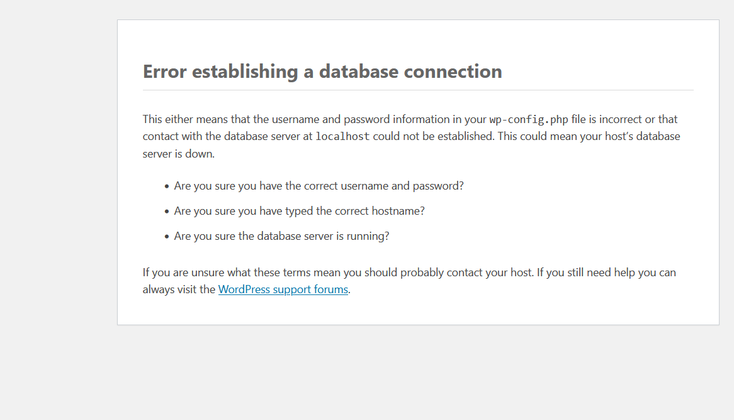 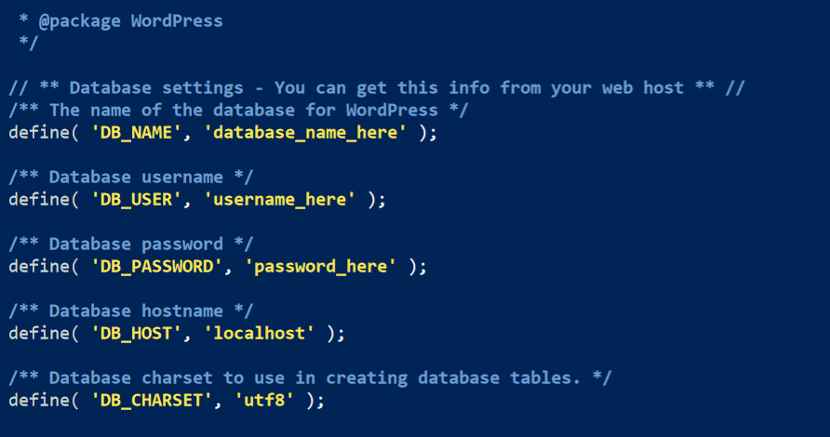 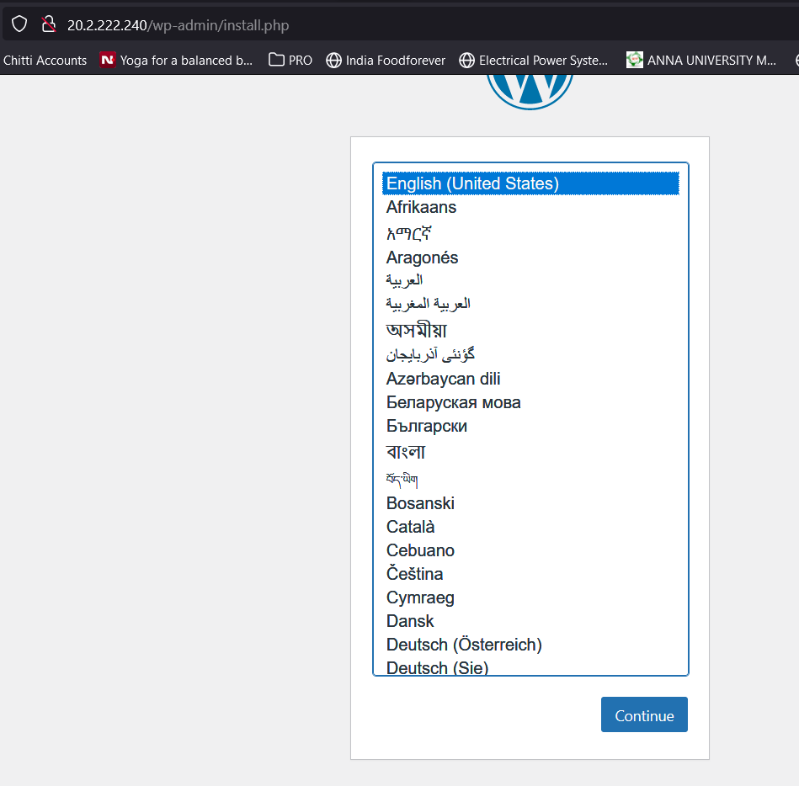

* + Follow the on-screen instructions to complete the WordPress installation.

When prompted, enter the database name, username, password, and database host (usually 'localhost') you configured earlier.

* + Complete the WordPress installation by providing site information such as site title, username, password, and email address.

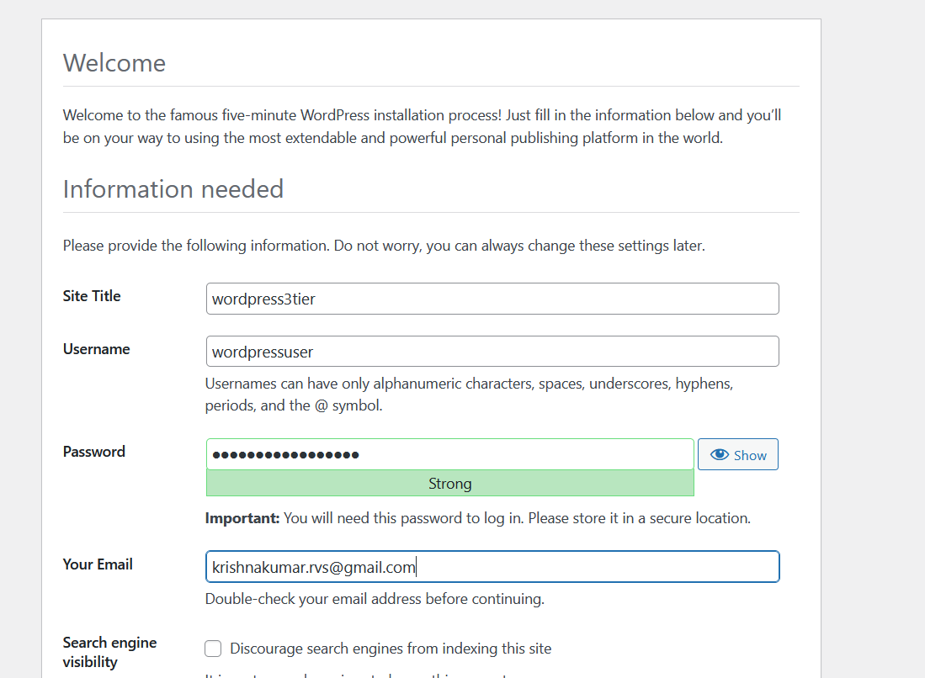

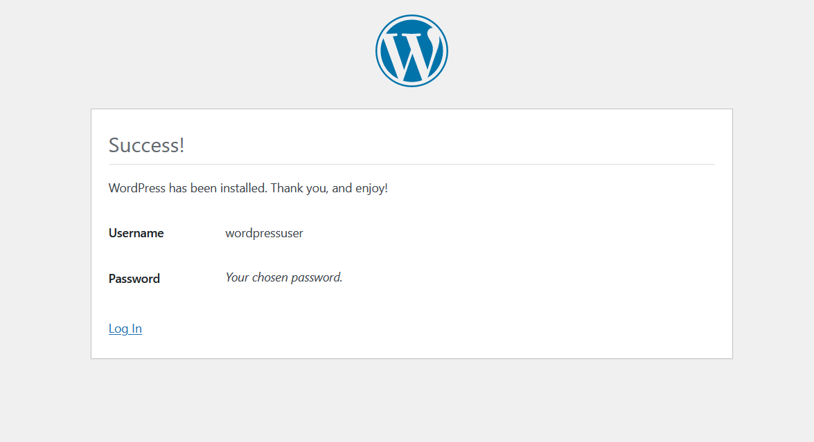

1. **Customize WordPress**:
   * Log in to the WordPress admin dashboard using the credentials you created during installation.
   * Customize WordPress settings, install themes, and plugins as per your requirements.
   * Upload your content and configure additional settings as needed.
2. **Secure WordPress**:
   * Implement security best practices such as using strong passwords, keeping WordPress core, themes, and plugins updated, and installing security plugins like Wordfence or Sucuri.

By following these steps, you can install and configure WordPress on your web server VM, connect it to the MySQL database server, and customize it according to your website's requirements.

* Set the correct permissions for the WordPress files:
* bash
* •
* sudo chown -R www-data:www-data /var/www/html/
* sudo chmod -R 755 /var/www/html/
* **Configure WordPress:**
* Create a configuration file for WordPress based on the sample provided:
  + css
  + sudo cp /var/www/html/wp-config-sample.php /var/www/html/wp-config.php
  + sudo nano /var/www/html/wp-config.php
* 
* 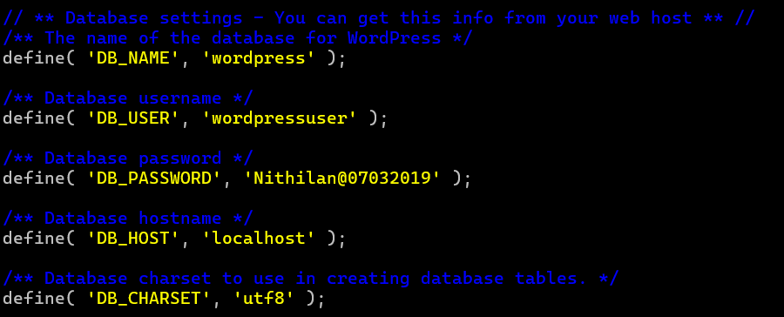
  + Update the database connection settings with the database name, username, and password you created earlier.
* **Complete WordPress Installation:**
* 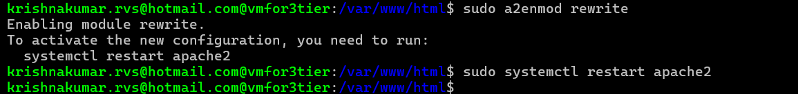Access your VM's public IP address or domain name in a web browser.

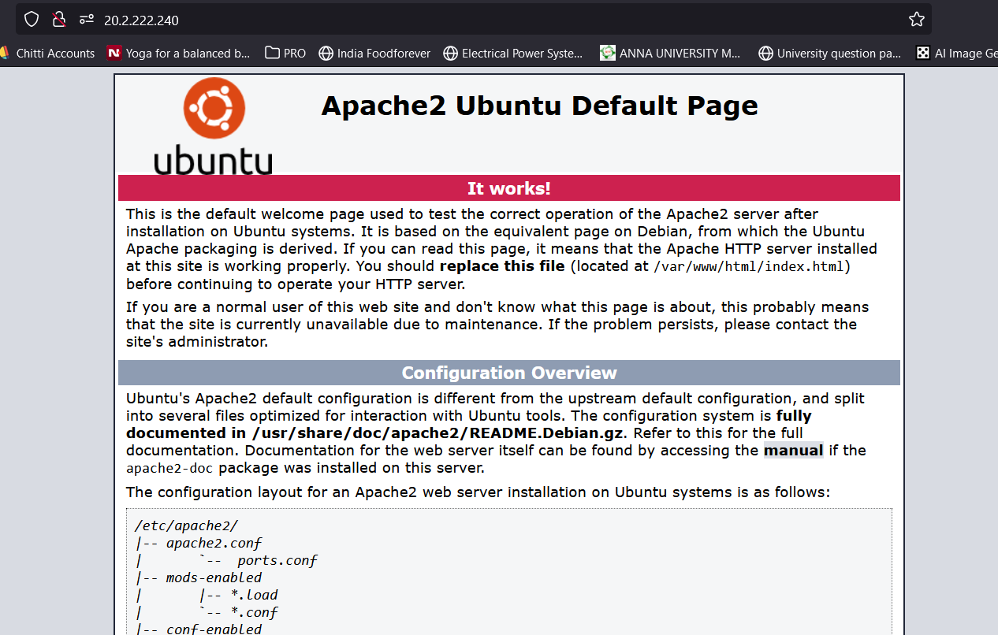

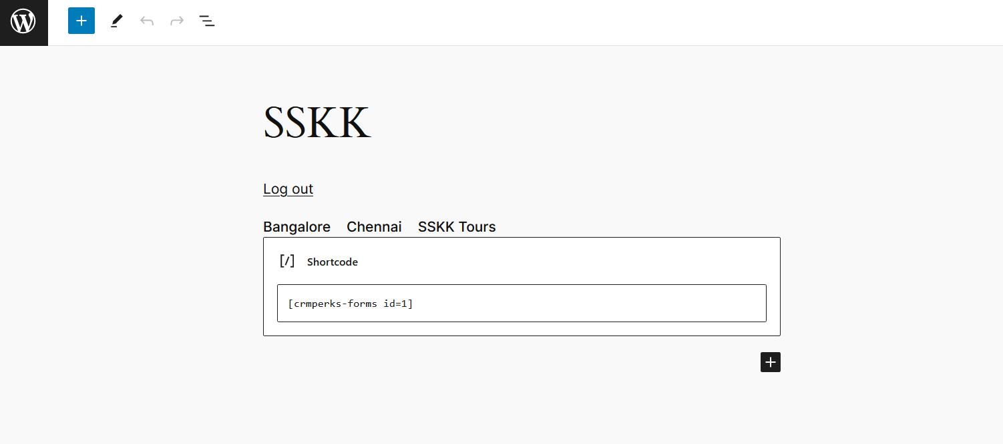 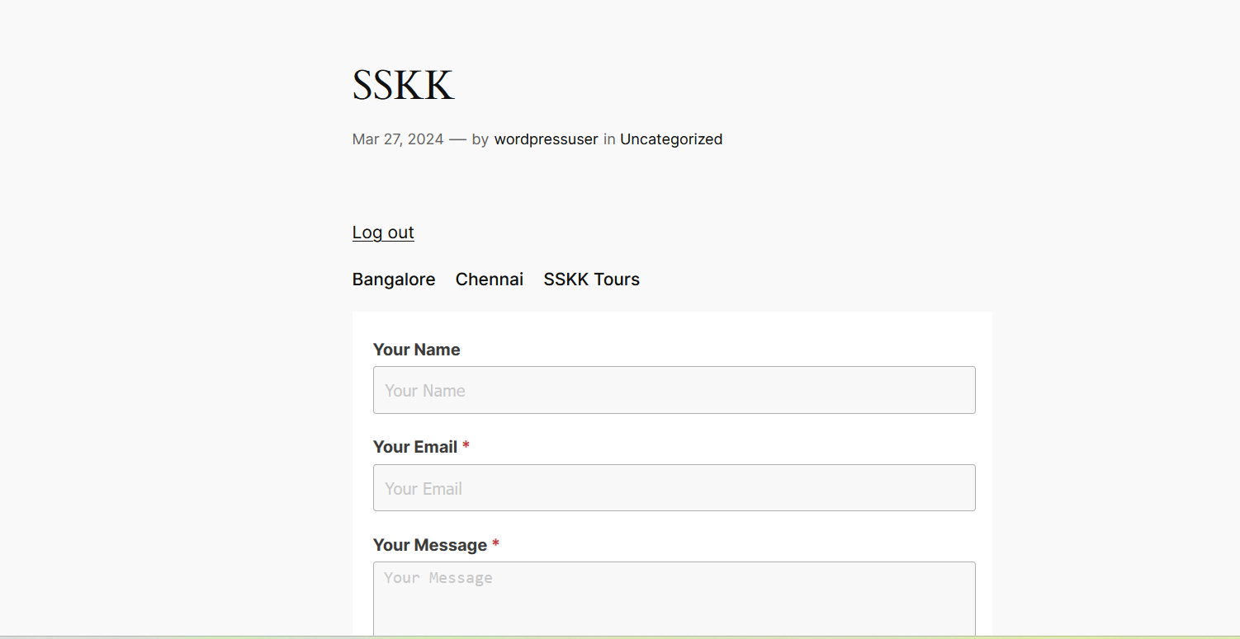 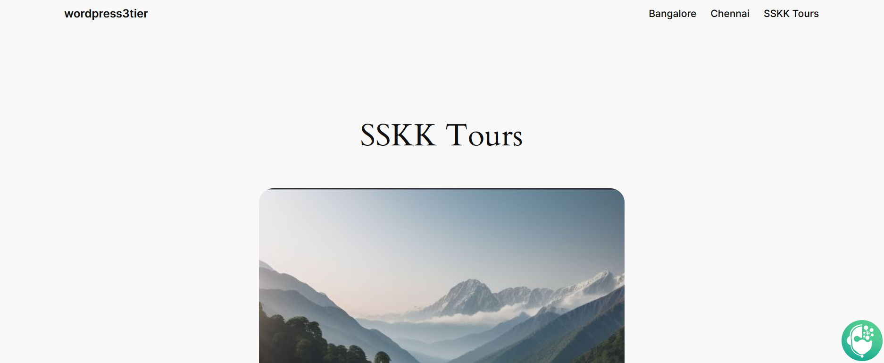 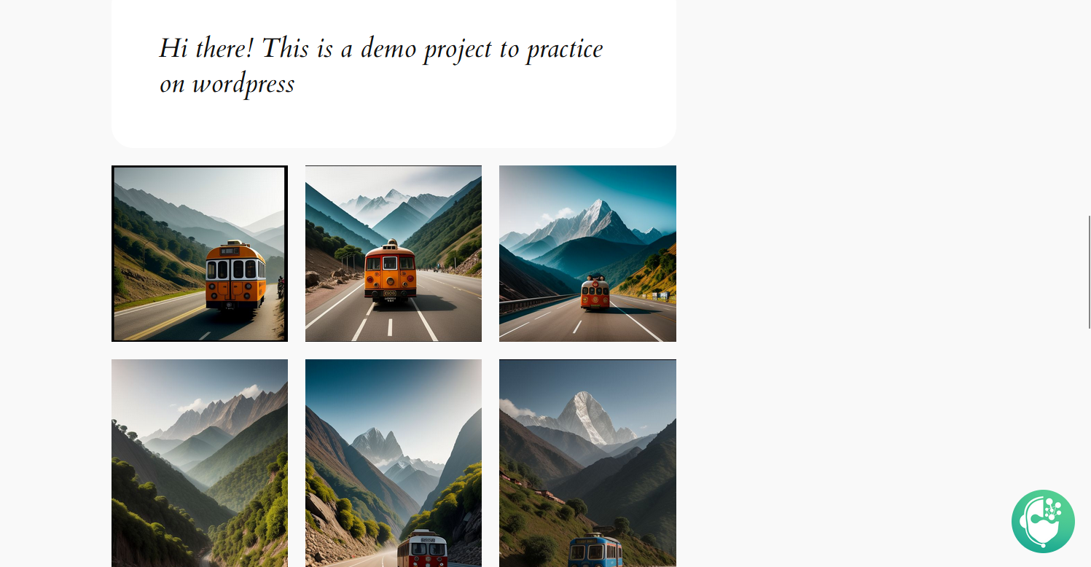

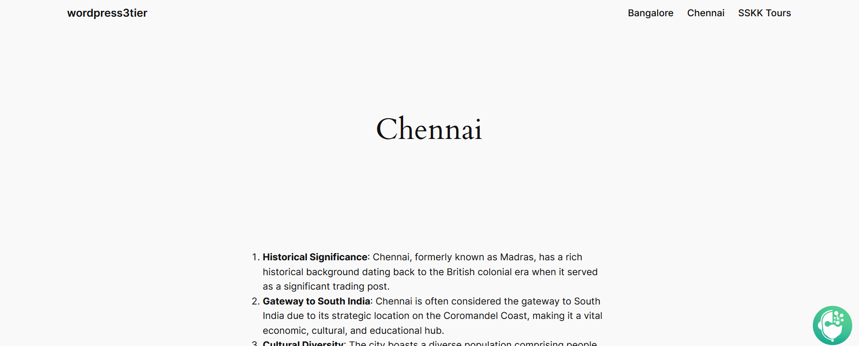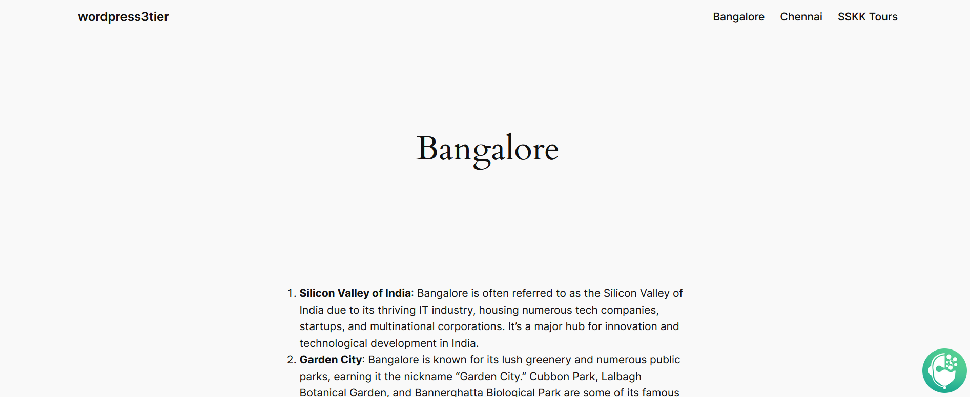

To configure security groups and autoscaling for your three-tier WordPress site on AWS, you'll need to set up security groups to control traffic flow and define scaling policies to handle varying levels of load. Here's a step-by-step guide:

**1. Configure Security Groups:**

**For VM1 (WordPress Site):**

* Verify the security group with inbound rules allowing traffic on ports 80 (HTTP) and 443 (HTTPS) from anywhere.
* Allow outbound traffic to the internet.

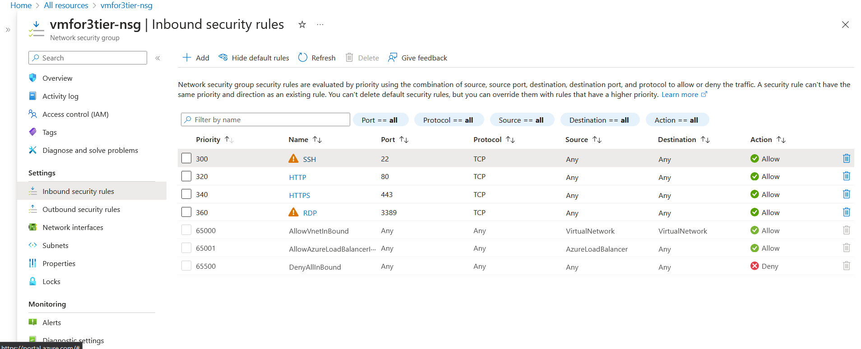 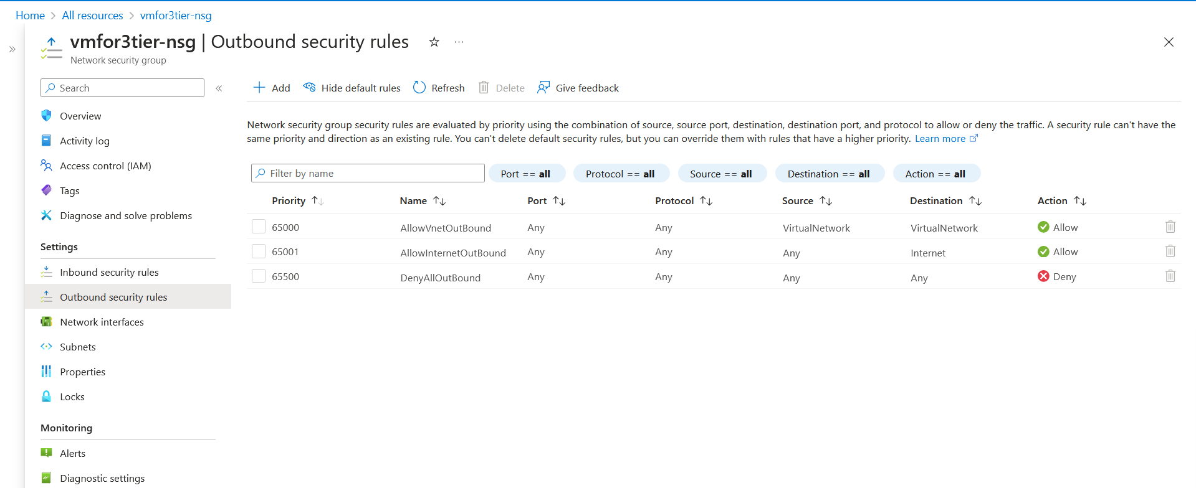

**For VM2 (PHP and other dependencies):**

* Verify the security group with inbound rules allowing traffic from the WordPress-security group on the ports required by your PHP application (e.g., 80, 443).
* Allow outbound traffic to the internet.

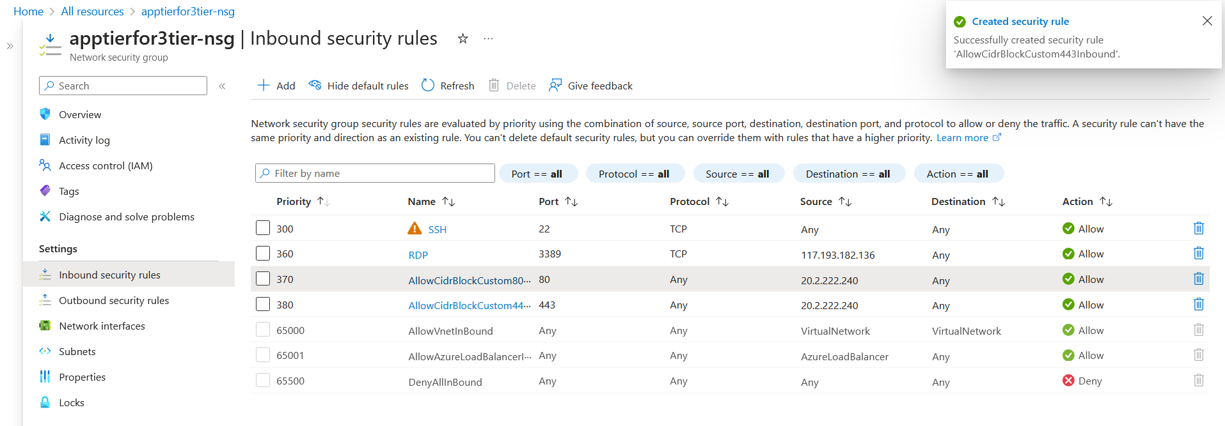

**For SQL Database:**

* Verify the security group with inbound rules allowing traffic from the PHP-SG security group on the port used by your SQL database (e.g., 3306).
* Allow outbound traffic to the internet.

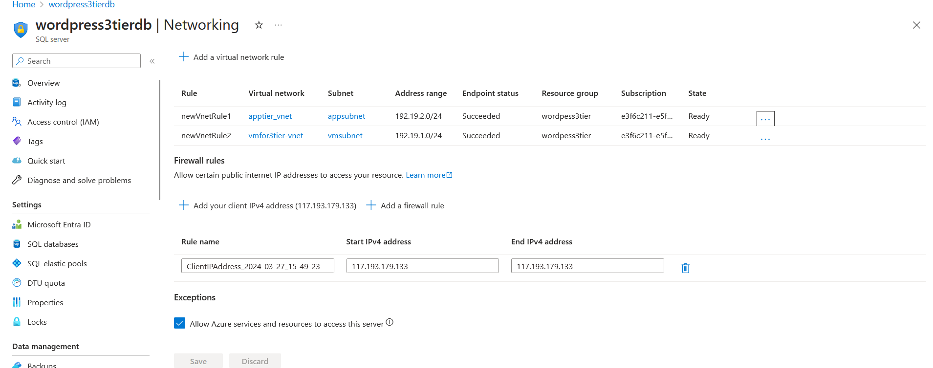

**2. Launch Configuration:**

* Create a launch configuration for your auto scaling group specifying the AMI, instance type, key pair, and security groups.
* Use the launch configuration to ensure that all instances launched by the auto scaling group have the necessary configurations and security groups.

**3. Auto Scaling Group:**

* Create an auto scaling group and attach the launch configuration to it.
* Define scaling policies based on metrics such as CPU utilization or request count to automatically adjust the number of instances in the group.
* Set minimum and maximum capacity limits to ensure that the auto scaling group scales within specified bounds.

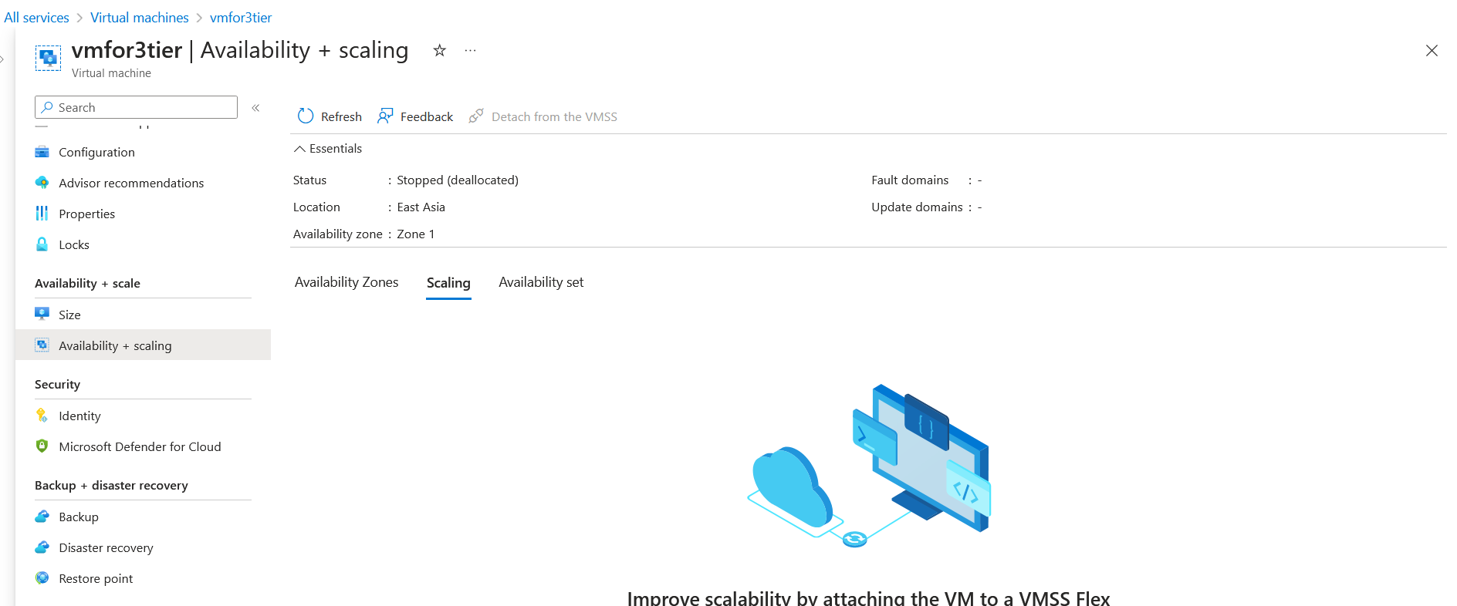

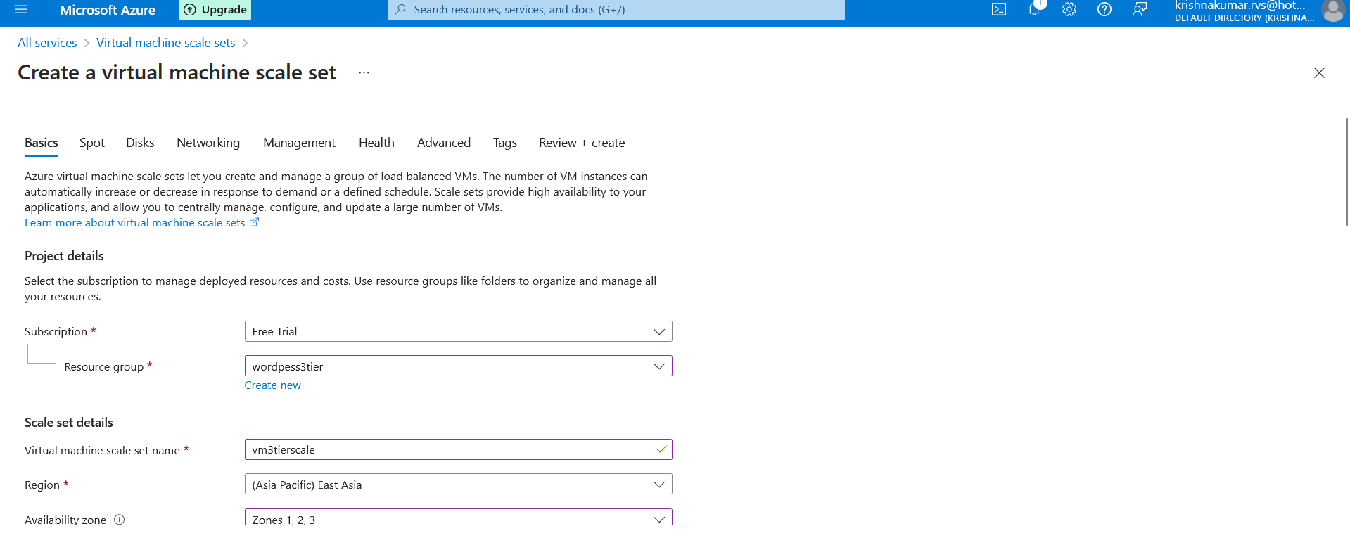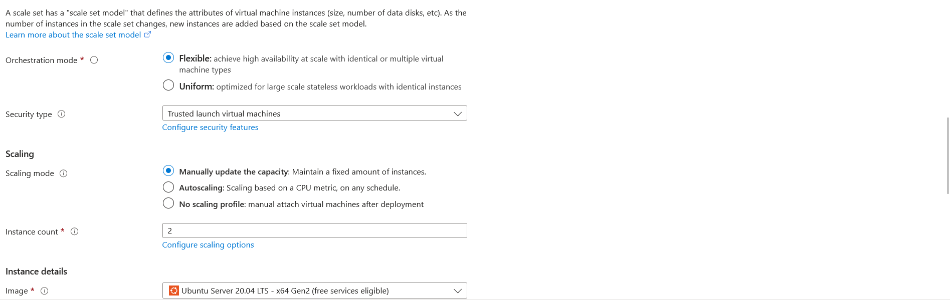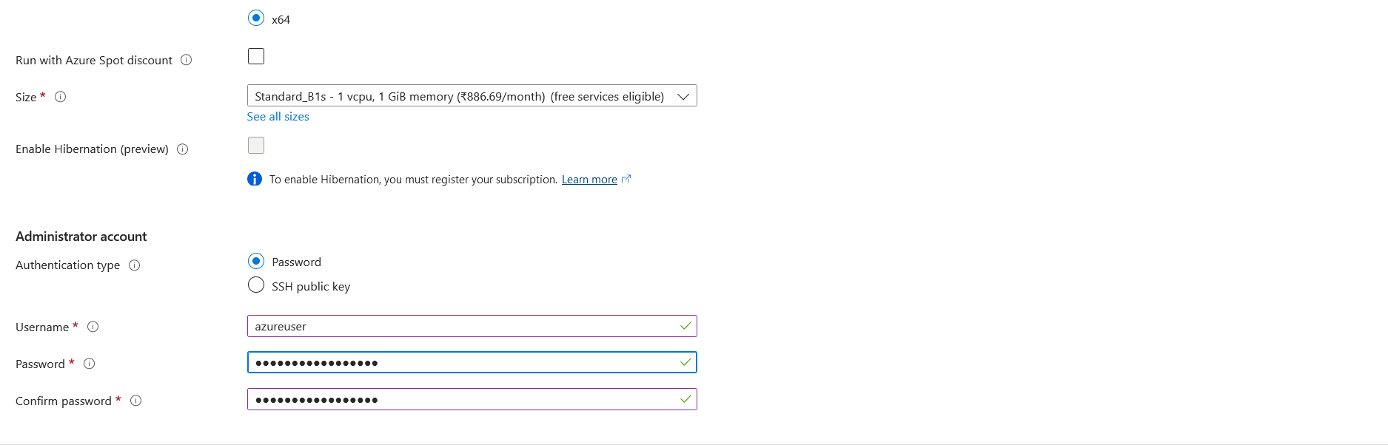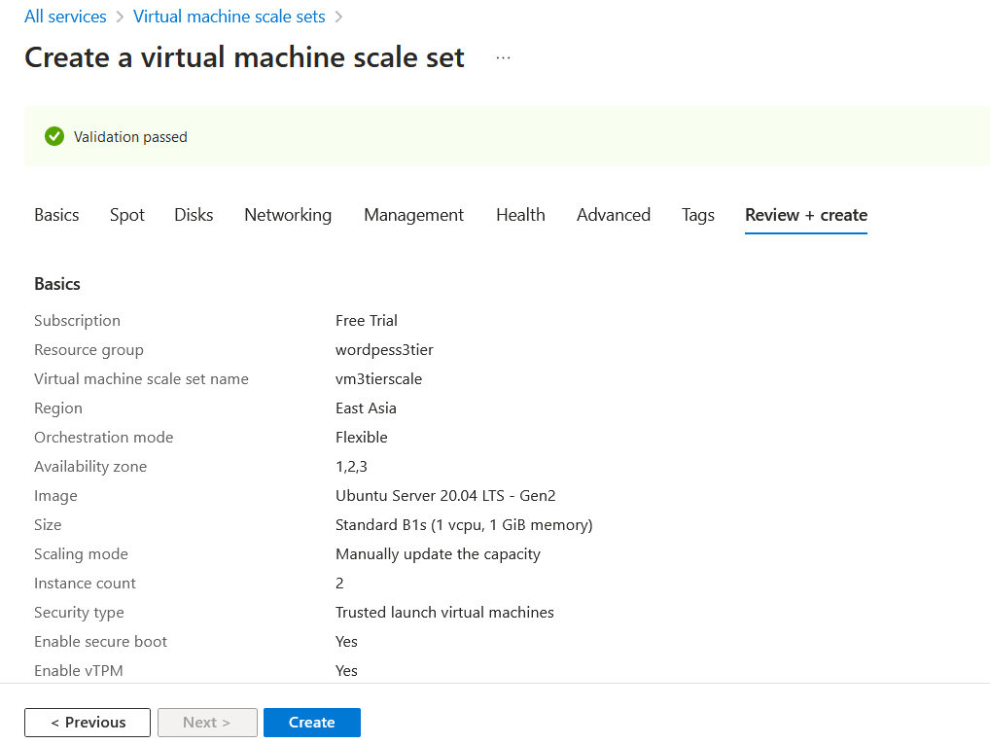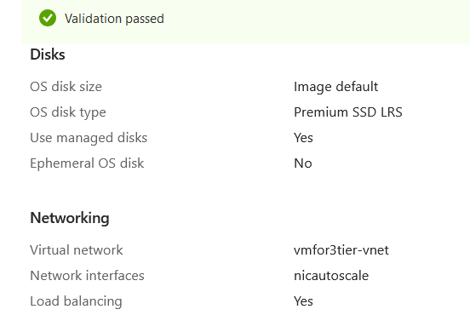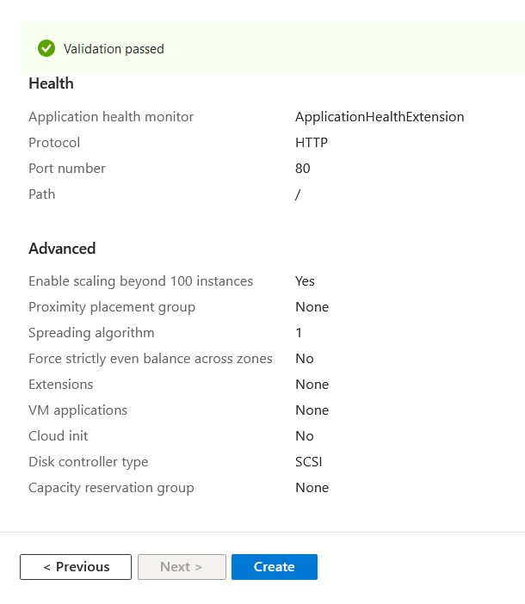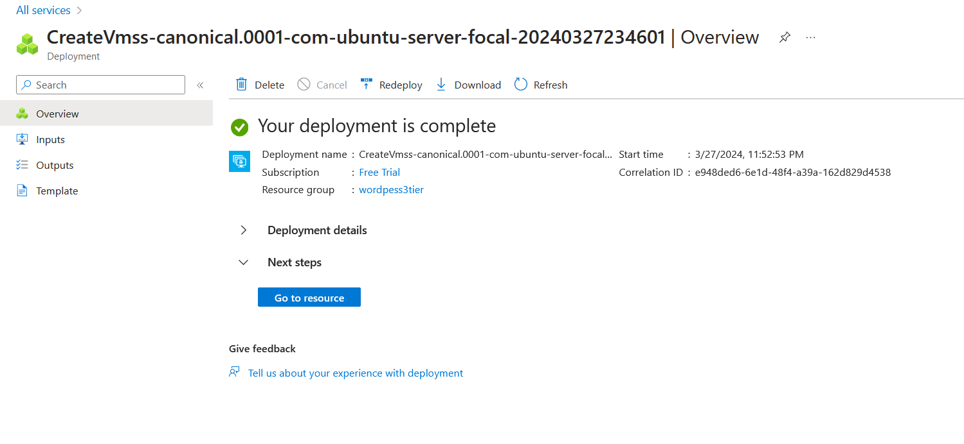

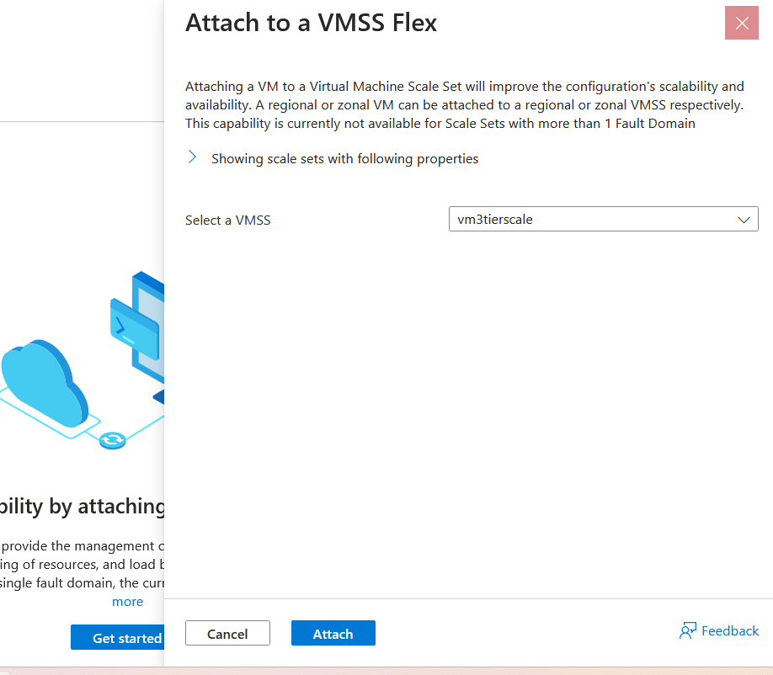



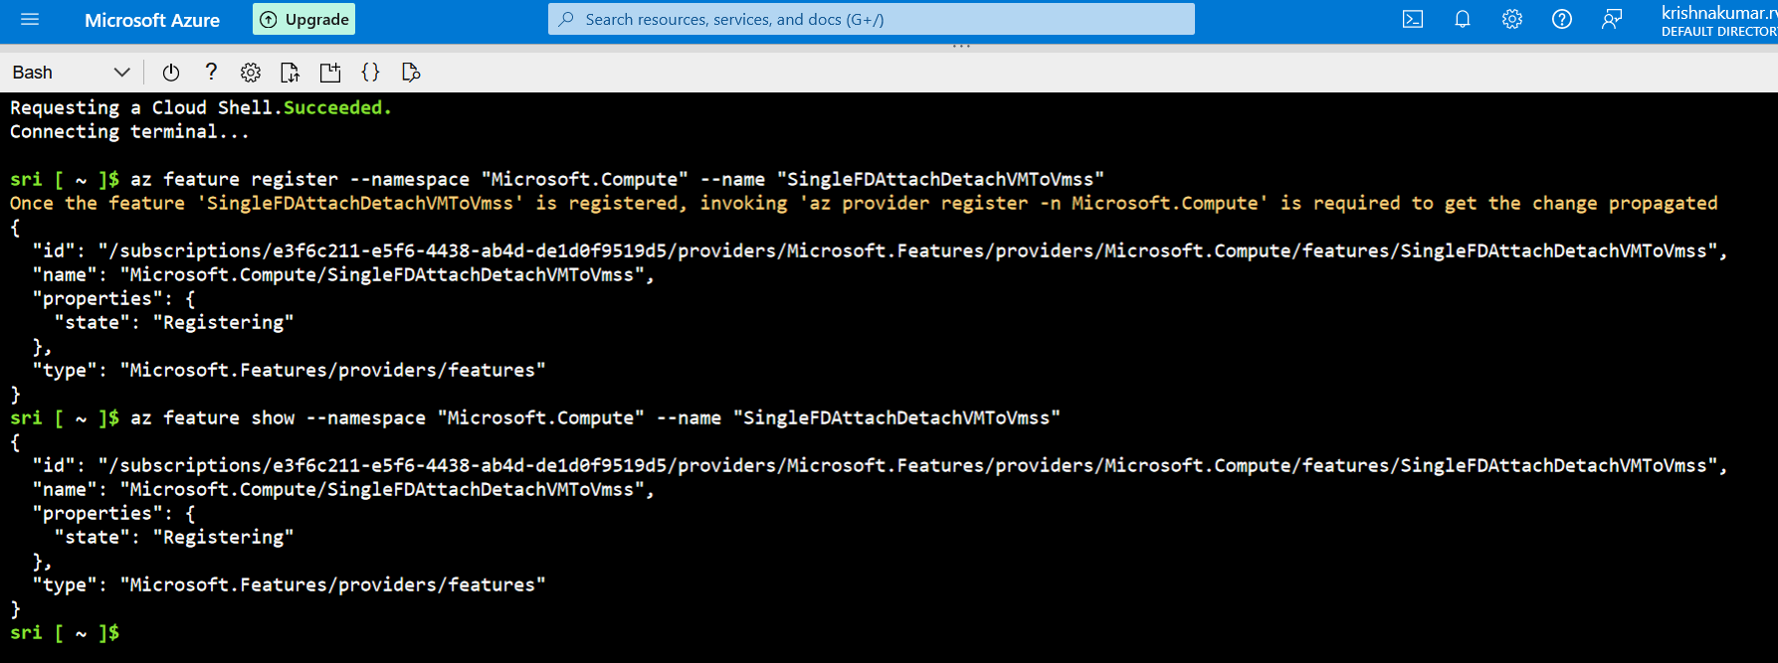

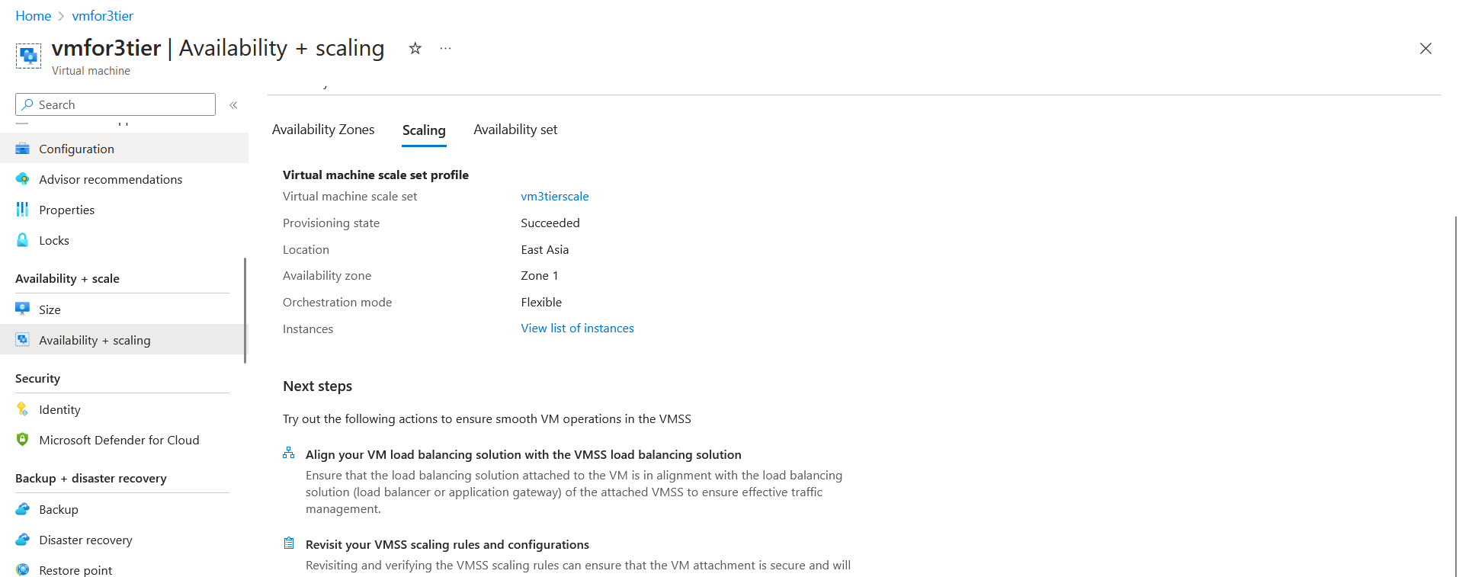

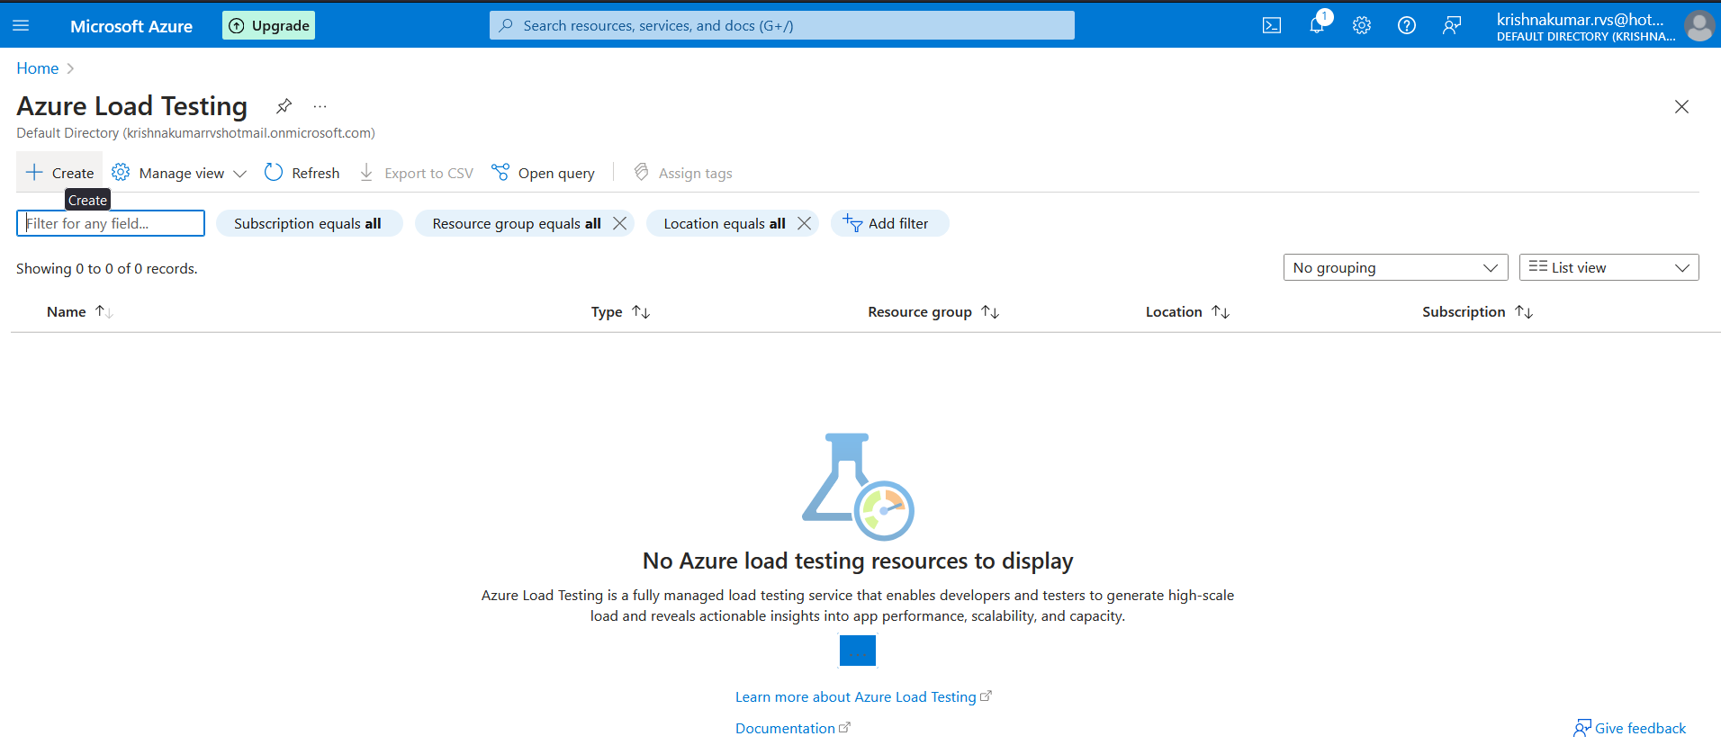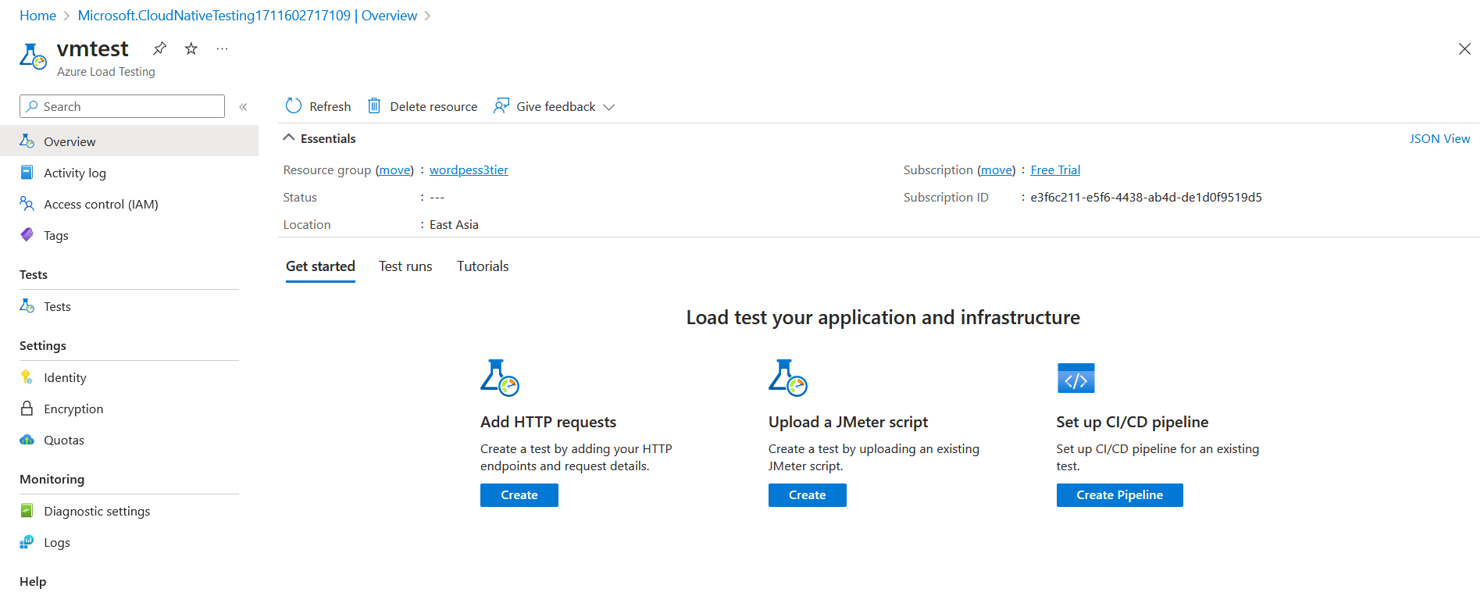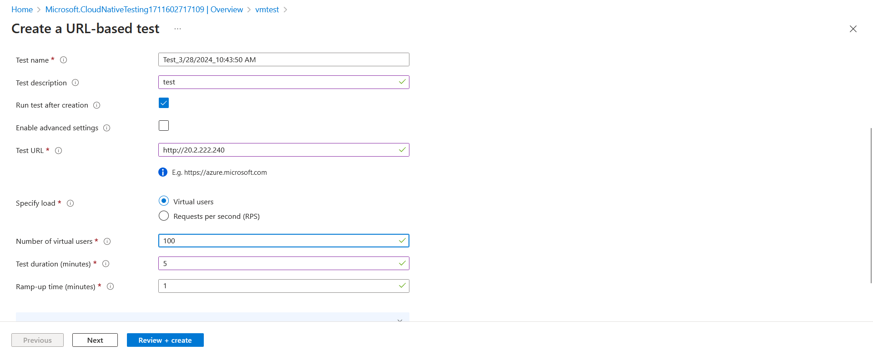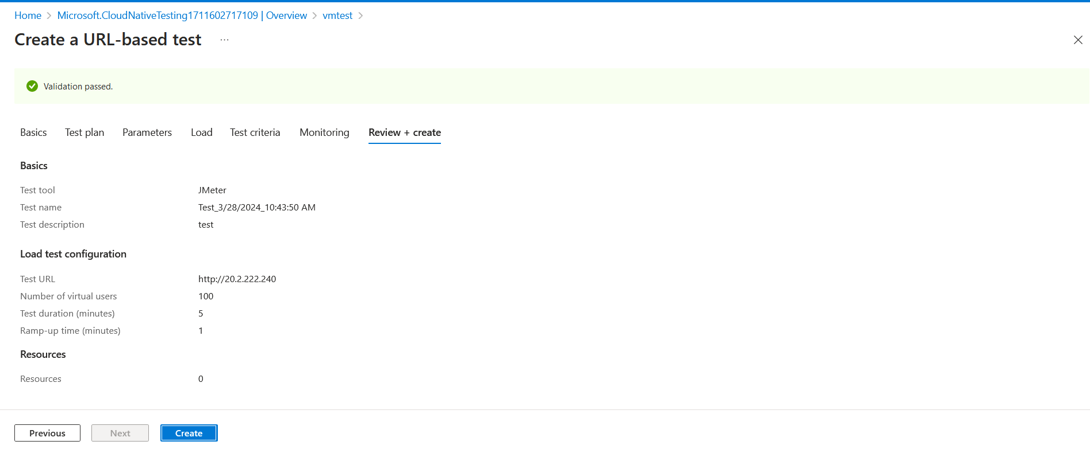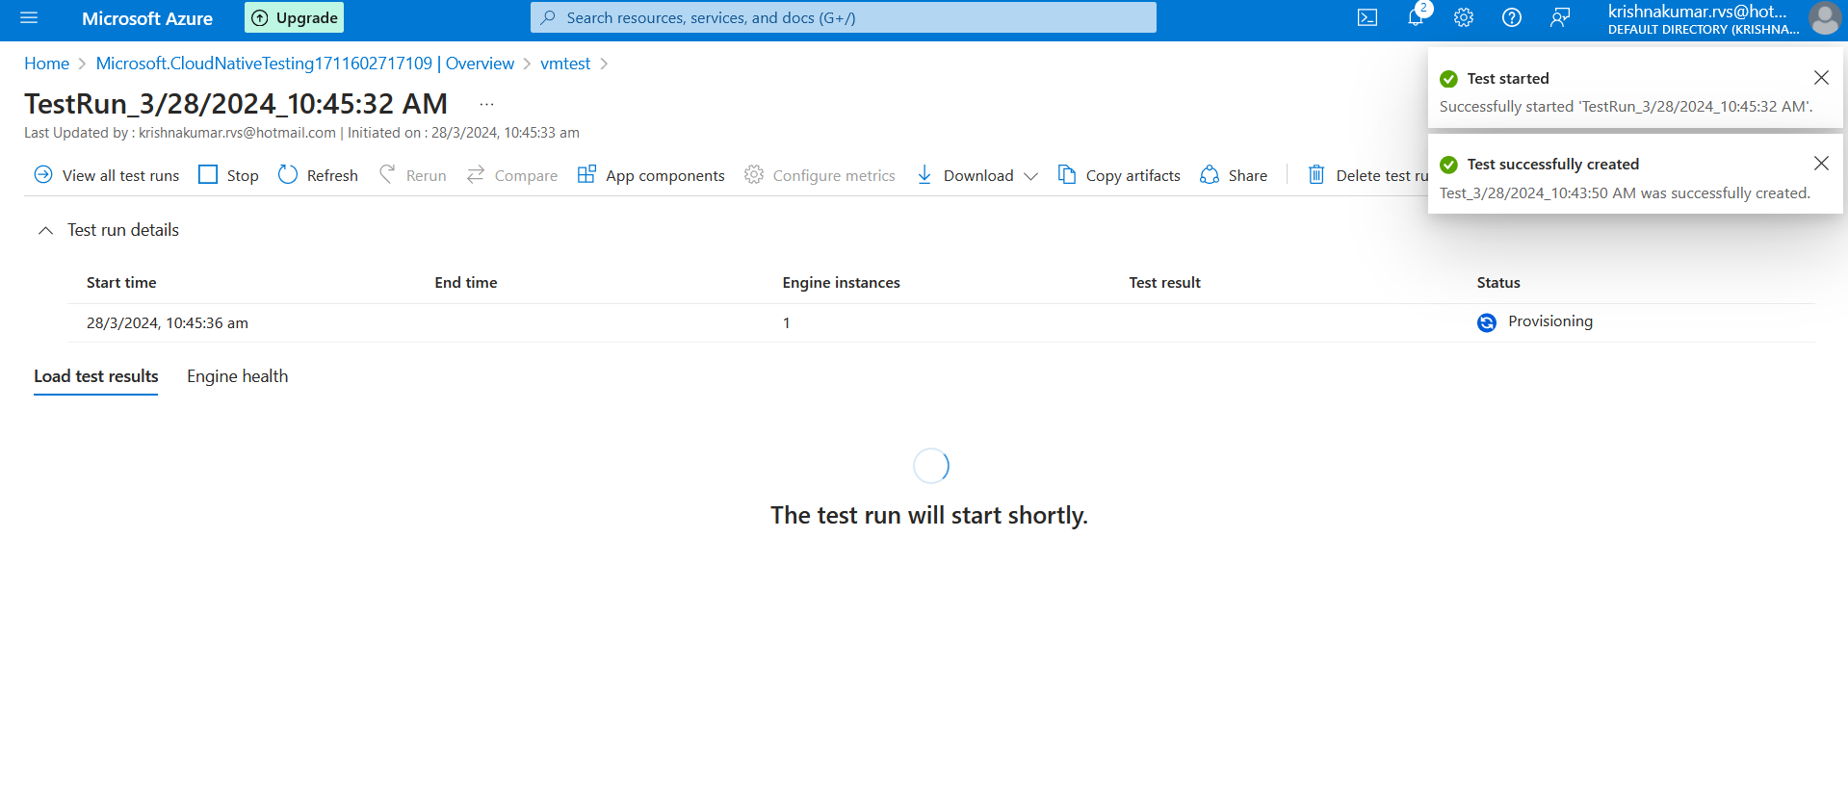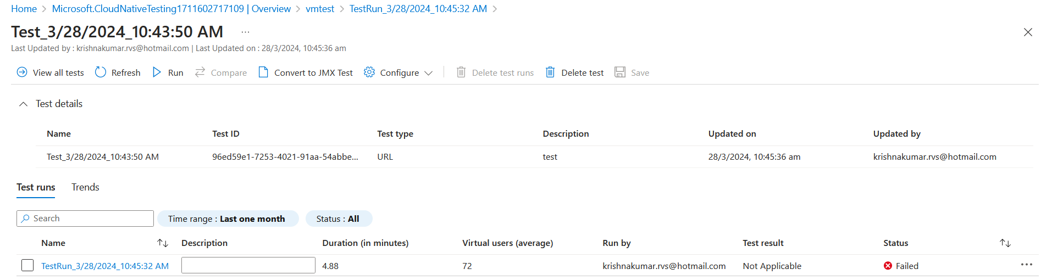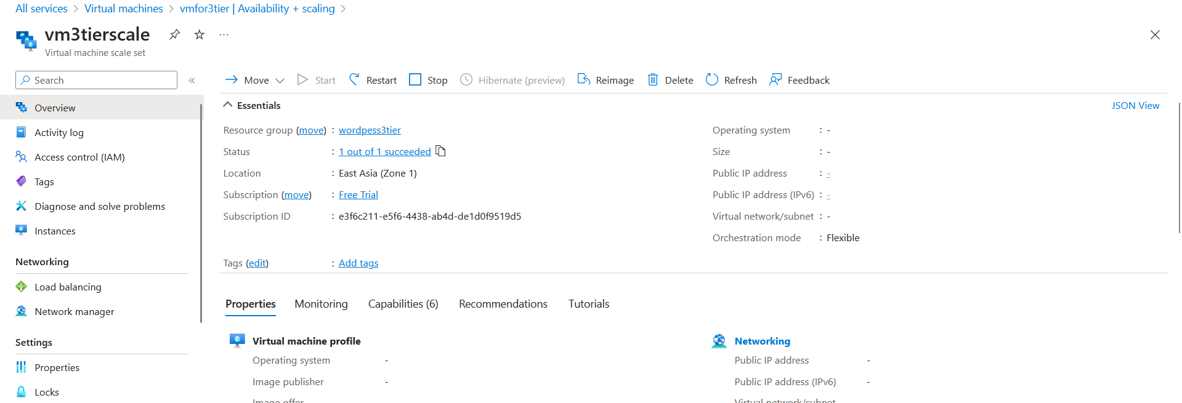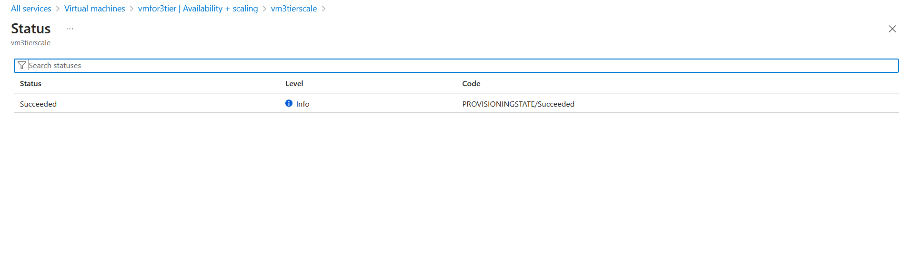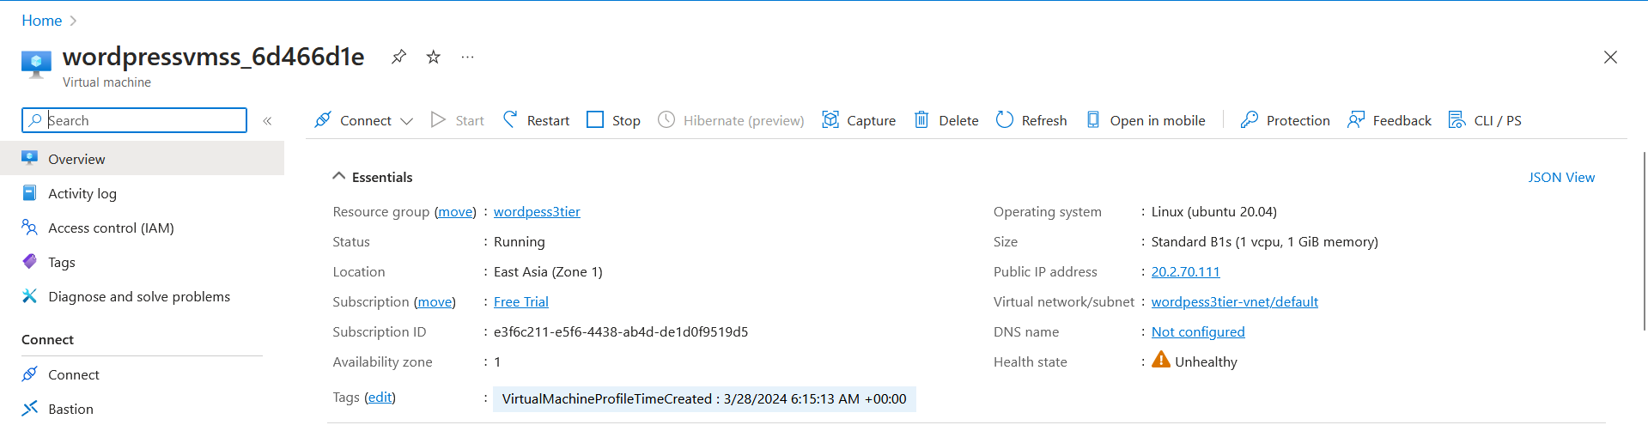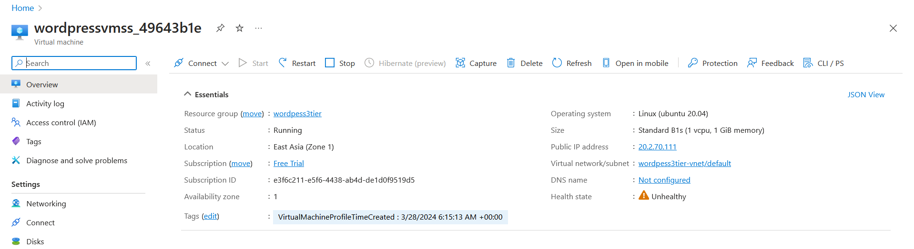

**Additional Considerations:**

* Configure health checks to ensure that only healthy instances are serving traffic.
* Enable CloudWatch alarms to receive notifications when scaling events occur or when there are issues with your instances.
* Implement logging and monitoring to track performance metrics and diagnose issues.
* Regularly review and update your security group rules and scaling policies to adapt to changing requirements and traffic patterns.